Virtually No-Carb Flatbread Buns for Two

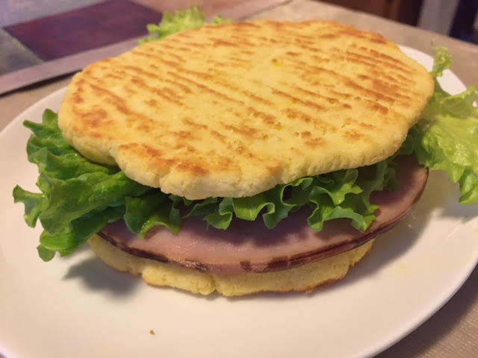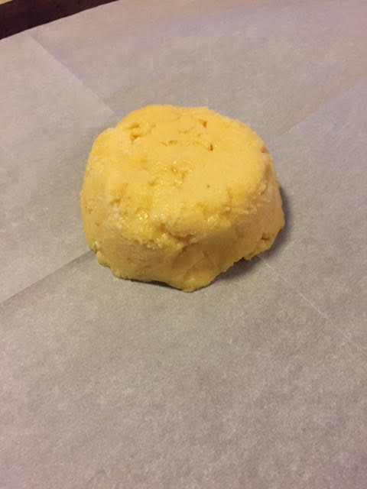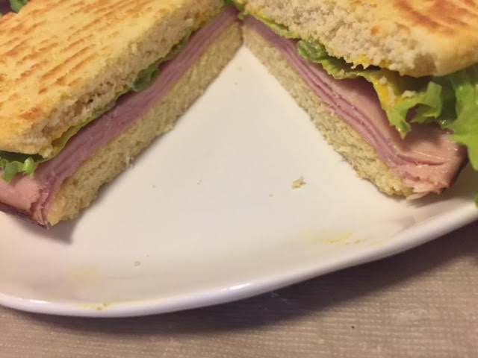

This recipe is a winner! It’s a good, virtually carb-free replacement for hamburger buns or for making sandwiches. It closely resembles whole-grain white bread in taste and texture, though it’s much more dense and filling. Also, there’s just the slightest hint of coconut flavor, but it compliments the bread very well. This recipe makes enough for two upper “buns” and 2 lower. Or spread some tomato sauce on them and garnish with your favorite toppings to make nice, little thick-crust individual pizzas (just pop them under the broiler to melt the cheese)!

Ingredients:
½ cup coconut flour
4 tablespoons butter, melted
4 eggs, beaten
1 teaspoon regular table salt
1 teaspoon baking powder

Preparation:
Preheat oven to 350° F.

Melt the butter in the microwave for a few seconds until liquefied and steaming – mix in the baking powder. Mix the coconut flour and salt together with a whisk in a separate bowl until combined. Add in the beaten egg and mix well.

Let the batter sit long enough to allow the flour to absorb the liquid so that it gets to a doughy consistency. Divide the dough into 4 equal portions and roll them into balls. Place the dough balls on a parchment-lined baking sheet and gently flatten each into a circle the size of a hamburger bun – use your fingers to gently seal the cracked edges into smooth circles.

Bake for 10 minutes or until golden brown. Let cool before serving. They should develop a very nice toasted underside, which you’ll want to present as the outside of your sandwiches (like in the photos above)!

