New England Brown Bread (recipe makes 1 loaf with about eight 1-slice servings)

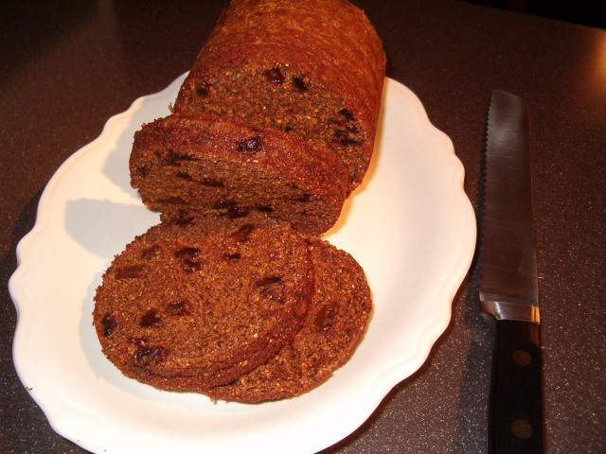

This bread, accompanied by Boston baked beans, makes a traditional supper on Saturday nights in New England. It's similar to (but much tastier than) the commercial brand sold in the can, which has been available throughout the U.S. in most supermarkets for as long as I can remember. Despite the raisins and molasses, this bread is not really sweet at all, and it goes perfectly with the Boston baked beans recipe.

You'll need a 16-ounce (1 pound) coffee, fruit or vegetable can for this.

Ingredients:
1 tablespoon unsalted butter for greasing
1½ cups brown-bread flour (see notes below)
1 teaspoon baking soda
½ teaspoon salt
⅓ cup dark molasses
1 cup milk
½ cup raisins

Preparation:
Preheat the oven to 325° F.

Grease a 1-pound coffee, fruit or vegetable can really well. Mix together the flour, baking soda and salt in a bowl, then stir in the molasses and milk. Next, stir in the raisins.

Fill your can with the batter. It should come up about ⅔ of the way. Cover the top with foil and make sure the foil is secure and airtight (I tie it well with a length of water-soaked kitchen twine). Place the can in a deep baking pan and fill the pan with boiling water up to the halfway point up the side of the can.

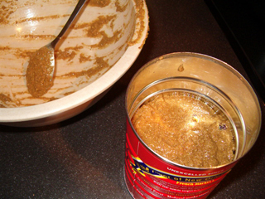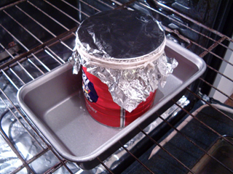
(You can't see it too well here, but the pan is full of water.)

Put it in the pre-heated oven and allow it to steam for two hours, checking the water level after about an hour - add more boiling water if necessary to insure it's up to the halfway mark on the can. To check if it's done, stick a toothpick in the bread; it will come out clean when done.

Remove the foil and allow the bread to cool in the can for a good hour before unmolding. Slice and serve slathered with butter - YUM!

Notes:
Brown-bread flour is a specialty mixture of New England made of whole-wheat flour, rye flour and cornmeal or johnnycake meal. It's available in some stores already mixed, or you can make your own easily enough by just combining equal parts of wheat and rye flour and cornmeal.

If you don't like raisins in your bread, you may leave them out - just make sure you add a tablespoon of vegetable oil to the batter to replace the lost moisture (the bread then tastes like raisin-bran breakfast cereal without the raisins - it's good).

The bread freezes just fine. Try it toasted!

