Muffulettas - recipe makes two big sandwiches (you can freeze what you don’t eat)!

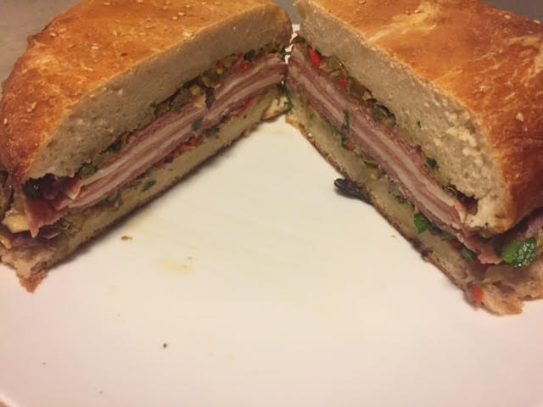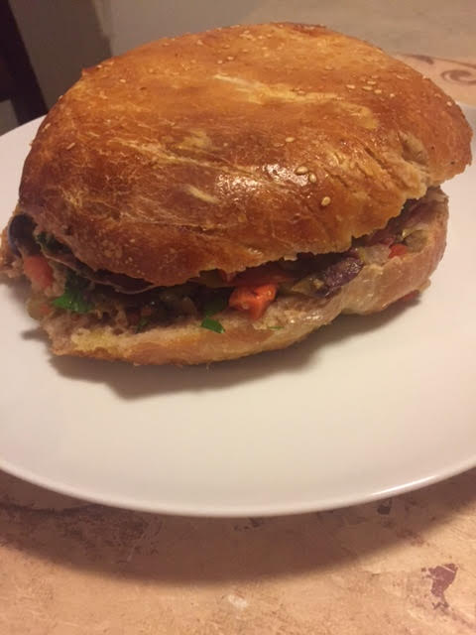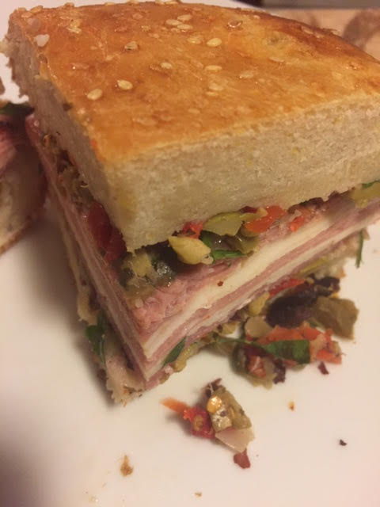

This sandwich was first put together by the proprietors of Central Grocery in the heart of New Orleans’ French Quarter over a hundred year ago for Italian immigrant workers. If you like a spicier sandwich, increase the amount of pepper flakes.

- Ingtredients:
- 2, 1-pound balls pizza dough
- 2 cups drained jarred giardiniera (a 16-ounce jar, drained)
- 1 cup pimento-stuffed green olives
- ½ cup pitted kalamata olives
- 2 tablespoons capers, rinsed
- 1 tablespoon red wine vinegar
- 1 garlic clove, minced
- ½ teaspoon dried oregano
- ¼ teaspoon red pepper flakes
- ¼ teaspoon dried thyme
- ½ cup olive oil
- ¼ cup chopped fresh parsley
- 1 large egg, lightly beaten
- 5 teaspoons sesame seeds
- 4 ounces thinly sliced Genoa salami
- 6 ounces thinly sliced aged provolone cheese
- 6 ounces thinly sliced mortadella
- 4 ounces thinly sliced hot capicola

Preparation:
Starting with store-bought pizza dough means no mixing or kneading—just shape, rest, top, and bake. Form dough balls into 2 tight round balls on oiled baking sheet, cover loosely with greased plastic wrap, and let rise at room temperature for 1 hour.

Meanwhile, pulse giardiniera, green olives, kalamata olives, capers, vinegar, garlic, oregano, pepper flakes, and thyme in food processor until coarsely chopped, about 6 pulses, scraping down sides of bowl as needed. Transfer to bowl and stir in oil and parsley. Let sit at room temperature for 30 minutes. (Olive salad can be refrigerated for up to 1 week.)

Adjust oven rack to middle position and heat oven to 425° F. Keeping dough balls on sheet, flatten each into 7” disk. Brush tops of disks with beaten egg and sprinkle with sesame seeds. Bake until golden brown and loaves sound hollow when tapped, 18 to 20 minutes, rotating sheet halfway through baking. Transfer loaves to wire rack and let cool completely, about 1 hour. (Loaves can be wrapped in plastic and stored at room temperature for up to 24 hours.)

Slice loaves in half horizontally. Spread one-fourth of olive salad on cut side of each loaf top and bottom, pressing firmly with rubber spatula to compact. Layer 2 ounces salami, 1½ ounces provolone, 3 ounces mortadella, 1½ ounces provolone, and 2 ounces capicola in order on each loaf bottom. Cap with loaf tops and individually wrap sandwiches tightly in plastic (I put them in gallon Ziplocs).

Place baking sheet on top of sandwiches and weigh down with heavy Dutch oven or two 5-pound bags of flour or sugar for 1 hour, flipping sandwiches halfway through pressing. Unwrap and slice each sandwich into quarters and serve. (Pressed, wrapped sandwiches can be refrigerated for up to 24 hours, or frozen. Bring to room temperature before serving.) Sandwiches can be frozen just fine!

