Mock Garlic Mashed “Potatoes” (recipe makes 4 servings)

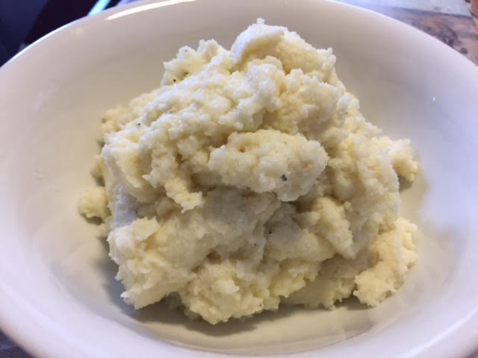

These are super tasty and delicious, and very easy to make! Use them as a low-carb substitute wherever a recipe calls for mashed potatoes (I make shepherd’s pie with them), or just serve a big, buttery scoop of them along with fried chicken, pork chops, or braised sausages all covered with gravy.

Ingredients:
1 medium head cauliflower
1 tablespoon cream cheese, softened
¼ cup grated Parmesan
½ - 1 teaspoon minced garlic, to taste
¼ teaspoon straight chicken base or bullion (may substitute ½ teaspoon salt)
Unsalted butter, to taste
Salt and ground black pepper, to taste

Preparation:
Bring a large pot of water to boil over high heat.

Clean and cut the cauliflower into small pieces. Cook in boiling water for about 6 minutes, or until well done – to the point you can easily pierce or cut the stems with a butter knife. Drain well; do not let cool and pat cooked cauliflower very dry between several layers of paper towels (I do them in 3 – 4 batches).

In a food processor, puree the hot cauliflower with the cream cheese, Parmesan, garlic, chicken base, butter, salt and pepper until almost smooth.

