Amazing Low-Carb Cauliflower Rice (recipe makes about 4 cups)

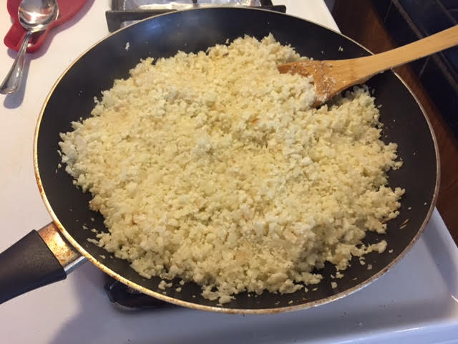

Ingredients:
- 1 large head cauliflower, separated into 1” florets
- 3 tablespoons olive oil
- 1 medium onion, finely diced
- Salt

Preparation:
Trim the cauliflower florets, cutting away as much stem as possible. In 3 batches, break up the florets into a food processor and pulse until the mixture resembles couscous. You really do need to process it in at least 3 batches (volume increases).

Heat the oil in a large skillet over medium-high heat. At the first wisp of smoke from the oil, add the onions, and stir to coat. Continue cooking, stirring frequently, until the onions are golden brown at the edges and have softened, about 8 minutes.

Add the cauliflower and stir to combine. Add 1 teaspoon salt, and continue to cook, stirring frequently, until the cauliflower has softened, 3 to 5 minutes. Remove from the heat.

Serve warm just like you would any kind of rice or couscous.

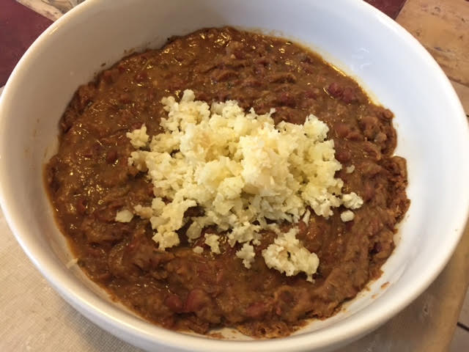 Creole Red Beans & “Rice”

