Leek and Potato Casserole (recipe serves 6 – 8)

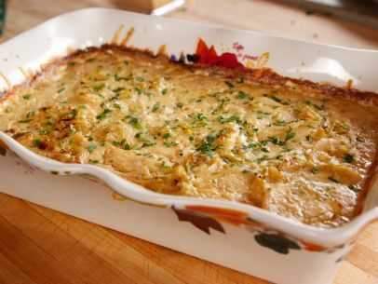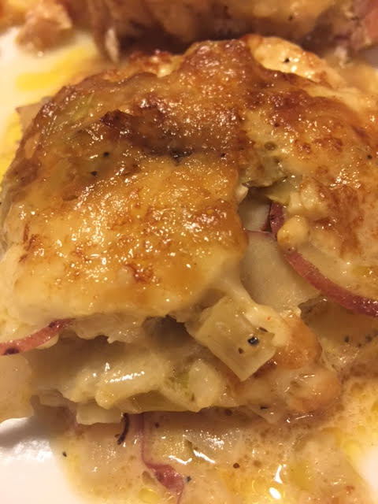

Ingredients:
2 tablespoons butter, plus more for the dish
2 leeks, halved, thinly sliced and soaked in cold water for 30 minutes
3 sprigs fresh thyme, leaves picked
Salt and ground black pepper
2 pounds Yukon gold potatoes, sliced thinly on a mandolin
8 ounces crème fraîche
½ cup heavy cream
½ cup chicken broth
2 cloves garlic, minced
¼ teaspoon paprika
1½ cups grated fontina cheese

Preparation:
Preheat the oven to 350° F. Butter an oval baking dish. Drain the leeks and rinse.

In a large saucepan, melt the butter over medium heat. Add the leeks and thyme, season with salt and pepper and cook, stirring, until the leeks are softened and golden.

Season the potato slices well with salt and pepper. Layer half of the potatoes in the buttered dish, then layer half of the cooked leeks over the potatoes. Repeat the layers.

Return the pot to medium heat and add the crème fraîche, cream, chicken broth and garlic. Stir together, scraping up any brown bits from the bottom of the pot. Sprinkle with the paprika and some salt and pepper. Bring to a boil, lower to a simmer and simmer until the crème fraîche melts. Pour the cream mixture over the leeks and potatoes and top with the grated cheese.

Cover with foil and transfer to the oven. Bake for 40 minutes, then remove the foil and continue baking until the cheese is bubbly and golden, 15 to 20 minutes more. Allow to cool slightly before serving.

