Old-School Ham & Bean Soup (recipe makes 6 – 8 servings)

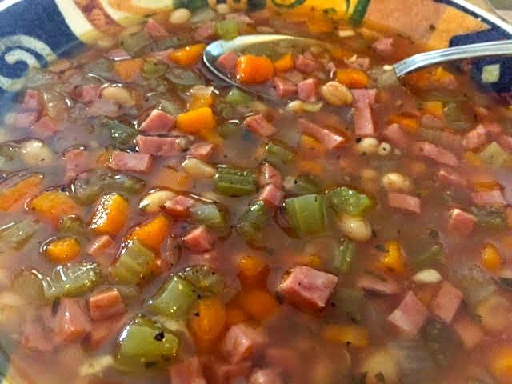

Ingredients:
2 15-ounce cans navy or small white beans, drained and thoroughly rinsed
2 cups (16 ounces) ham, diced the same size as your beans
4 cups ham and/or chicken stock
4 ribs celery, chopped into pieces the same size as the ham and beans
4 carrots, chopped into pieces the same size as the ham and beans
1 medium onion, diced into pieces the same size as everything else
3 cloves garlic, crushed and finely minced
1 teaspoon dried thyme
2 tablespoons fresh, chopped parsley or 1½ teaspoons dry
Salt and ground pepper, to taste (I season everything as I go)
2 tablespoons olive oil for sautéing vegetables (I use bacon grease!)

Preparation:
In large pot or Dutch oven, sauté the celery, carrots, onions and garlic in the oil over medium heat until tender. Add the stock, ham, beans, parsley and thyme.

Bring to a boil, then reduce the heat until it’s just “percolating” and simmer, covered, for 2½ hours. Check the seasoning before serving (I add a couple of teaspoons of my homemade Creole seasoning to it).

