Old Fashioned Fruit Cobbler (recipe serves 4 - 6)

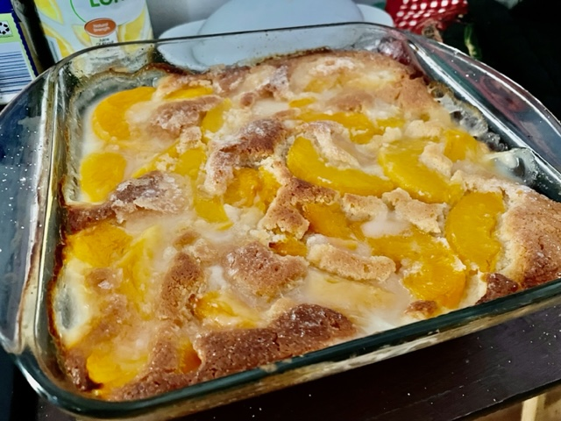

Ingredients:
4 cups any kind of fruit, fresh, frozen, or canned, sliced (sweetened to taste with more sugar, if using fresh or frozen fruit - if using canned, drain the fruit well)
4 ounces (1 stick) butter
1 cup self-rising flour (or just mix one cup all-purpose flour with 1½ teaspoons baking powder and ½ teaspoon salt)
1 cup sugar
1 cup milk

Preparation:
Preheat oven to 350° F. Melt butter in a 9” x 9” baking dish (I do it on low power/defrost in the microwave).

In a large bowl, mix together flour and sugar, then mix in the milk; whisk it in really well with the butter in the dish.

Spoon the fruit over the top, sprinkle more sugar over it (I use Splenda in the recipe, but I use regular granulated sugar to top it so it has a nice texture), and bake for 45 minutes, or until top is golden brown.

