**Cottage cheese flatbread**

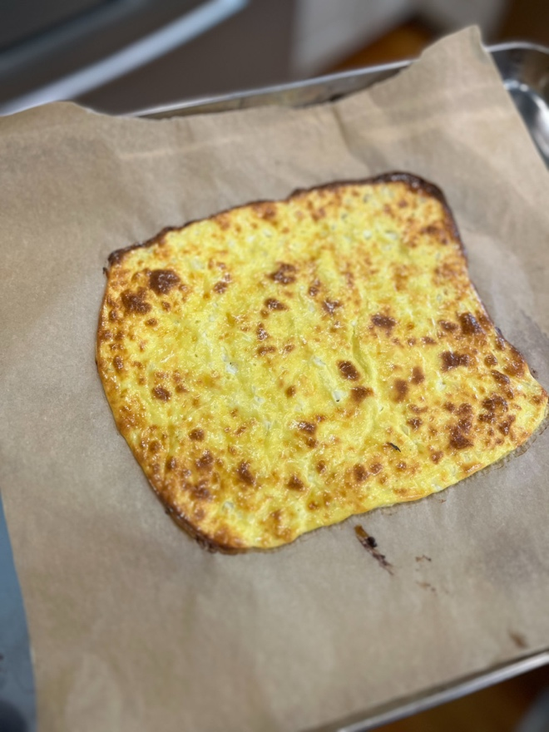

Mix one cup cottage cheese and two eggs until smooth in a food processor. Add salt, pepper and spices/herbs of choice. Bake at 350°F for about 20 minutes, until golden brown.