Big, Fat Chocolate Chip Cookies (recipe makes a dozen)

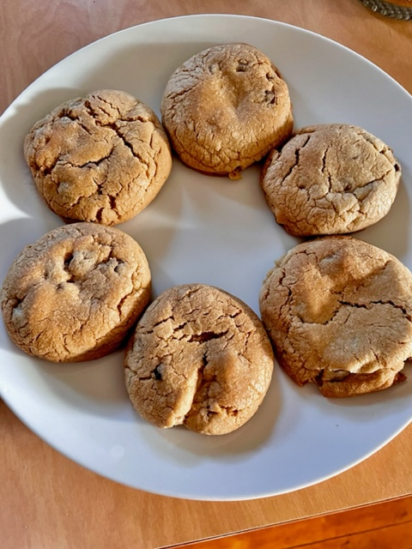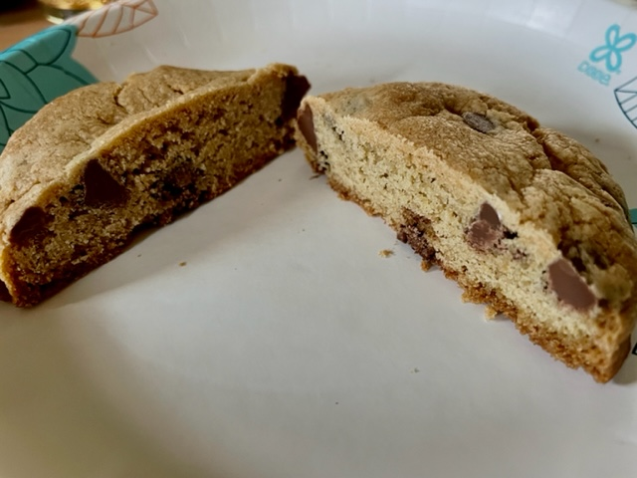

Ingredients:
- ½ cup (1 stick) butter, softened to room temperature
- ½ cup white sugar
- ½ cup packed brown sugar
- 1 egg
- 1 teaspoon vanilla extract
- ½ teaspoon baking soda
- 1 teaspoon hot water
- ¼ teaspoon salt
- 1½ cups all-purpose flour
- 1 cup chocolate chips (I like to use milk-chocolate chips)
- ½ cup chopped walnuts (optional)

Preparation:
Preheat oven to 350 degrees F.

Cream together the butter, white sugar, and brown sugar with an electric hand mixer until smooth. Beat in the egg, then stir in the vanilla. Dissolve baking soda in hot water. Add to batter along with salt. Take a big spoon and stir in flour, chocolate chips, and nuts, if including. Roll dough into a dozen equal sized balls with your hands and place evenly spaced apart onto ungreased baking sheets.

Bake for about 10 - 20 minutes in the preheated oven, or until edges are nicely browned. Let cool at least 5 minutes before devouring.

