Homemade “Chili Sauce” (recipe makes a smidge over 1 cup)

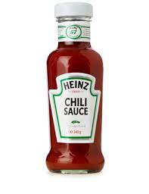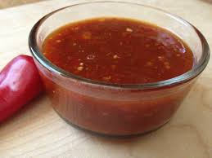

Just as good, if not better, than the store-bought brands!

Ingredients:
1 cup tomato sauce (I use Italian strained tomatoes – “pessata”)
2 tablespoons brown sugar
2 tablespoons distilled white vinegar
1½ teaspoons ketchup
½ teaspoon chili powder
¼ teaspoon ground allspice
¼ teaspoon granulated garlic powder
¼ teaspoon granulated onion powder
Salt & ground, black pepper, to taste
Crushed red-pepper flakes, to taste

Preparation:
Whisk all the ingredients together thoroughly in a 16-ounce measuring cup or bowl.

