Chicken Monterey for Two

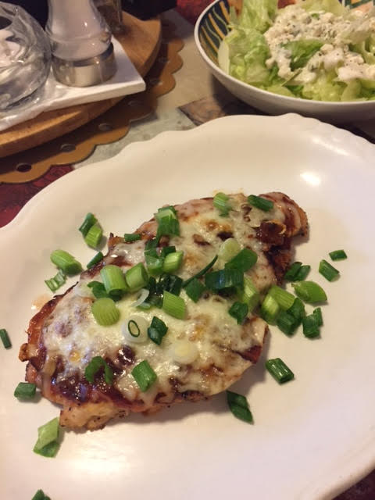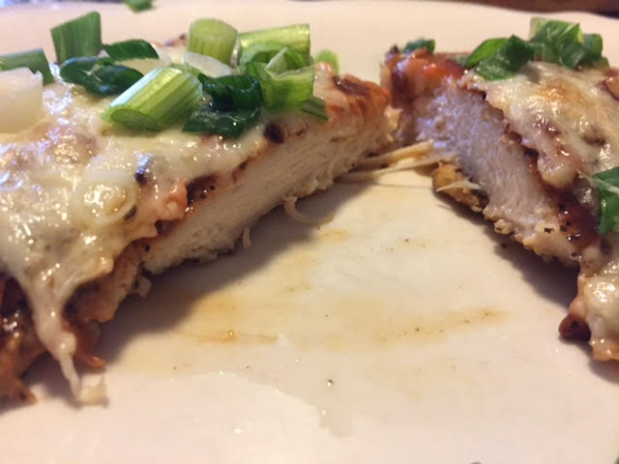

Chicken, bacon and cheese (and BBQ sauce) are a winning combination any time!

Ingredients:
4 slices bacon, chopped
2 chicken breasts, pounded to an even thickness
¾ teaspoon Lawry’s seasoning salt
½ cup barbecue sauce of your choosing
½ cup shredded Monterey Jack cheese
2 green onions, sliced
Ground, black pepper, to taste

Preparation:
Preheat oven to 350° F.

While the oven heats up, fry the bacon in a large (12”) skillet until crispy, then remove it from the pan. Remove all but about 2 tablespoons of the drippings from the skillet.

Season the chicken breasts on both sides with the Lawry’s seasoning salt and ground, black pepper; brown them in the bacon drippings over medium-high heat for 4 to 5 minutes on each side.

Place the browned chicken breasts in a large, greased baking dish; top them evenly with the barbecue sauce, bacon and cheese.

Cover the pan with aluminum foil and bake for 15 minutes in the preheated oven, then bake, uncovered, for an additional 10 minutes. Garnish with the green onions.

