Country Cabbage Soup (a Southern favorite!) – recipe serves 8

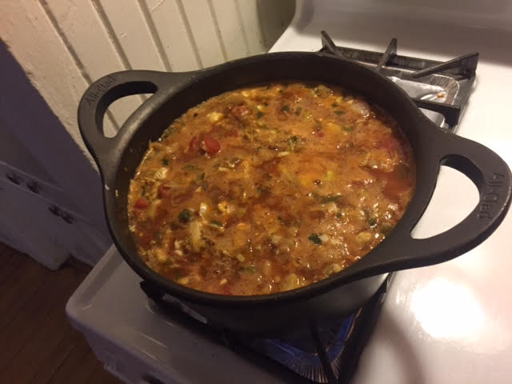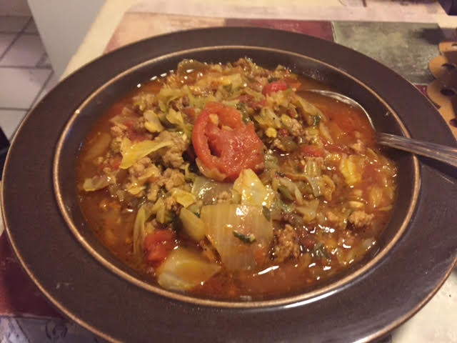

Perfect on a rainy day, this soup is simple to make and surprisingly filling.

Ingredients:
½ small head cabbage, chopped
2 pounds of lean ground beef and/or country sausage
1 15-ounce can of stewed or diced tomatoes.
1 10-ounce can diced tomatoes with green chilies, such as Ro*Tel
2 8-ounce cans of tomato sauce
1 large onion, chopped
4 ribs celery, finely chopped
1 small green bell pepper, finely chopped
Diced potatoes and/or cauliflower (for low-carb version), to taste
3 cups beef broth
Cayenne pepper, to taste
Chili powder, to taste
4 cloves of garlic, minced
¼ teaspoon smoky Spanish paprika.
½ teaspoon salt
½ teaspoon ground black pepper
½ teaspoon Creole seasoning
¼ teaspoon Lawry’s seasoned salt
1 tablespoon peanut or vegetable oil
4 tablespoons unsalted butter

Preparation:
In a Dutch oven or large pot, heat the oil and sauté the ground meat until it’s crispy. Add the celery, onion, bell pepper and garlic; sauté until translucent. Melt in the butter and add the cabbage; simmer until the cabbage is tender and wilted, then add in the rest of the ingredients and simmer on medium-low heat until potatoes/cauliflower are soft and tender.

Feel free to add anything you like such as green beans, corn, lentils or any other vegetable. I like plenty of Tabasco sauce in mine!

