Butter-Lemony Oakie Chicken Wings for Two

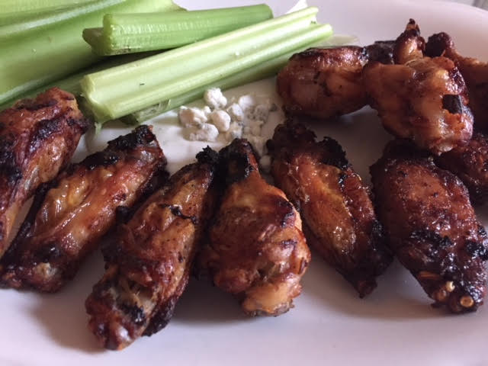

This recipe’s marinade works great for grilling regular chicken pieces, too.

Ingredients:
1¼ pounds chicken drumettes (5 – 6 per person)
- ½ cup (4 tablespoons) butter
- ½ cup lemon juice
- ¾ teaspoon Worcestershire sauce
- ¾ teaspoon Lawrey’s seasoned salt
- ¾ teaspoon lemon pepper
¼ teaspoon cayenne, or to taste

Preparation:
Melt the butter in a saucepan or zap it in the microwave for 30 seconds. Stir in the lemon juice, Worcestershire, seasoned salt, lemon pepper and cayenne. Toss the chicken pieces with the mixture until thoroughly coated and let them marinate 1 hour (I seal them up in a Ziploc bag).

When ready to cook the wings, preheat the oven to 375° F. Arrange the wings in a single layer on a baking sheet and bake them for 45 minutes, turning halfway through, until crisp and golden.

