Bread Pudding (recipe makes 4 – 6 servings)
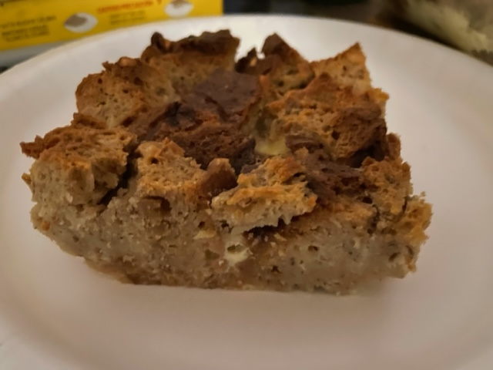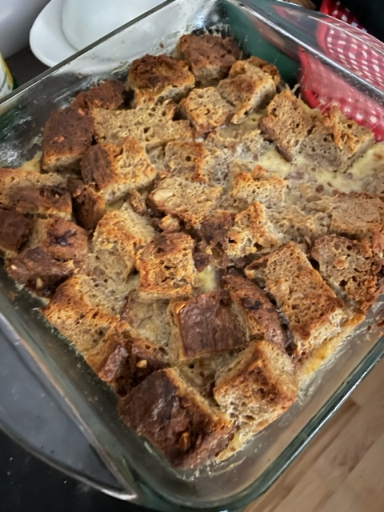
Ingredients:
2 cups milk
2 tablespoons (¼ stick) unsalted butter, more for greasing pan
1 teaspoon vanilla extract
1 teaspoon cinnamon
⅓ cup sugar
1/8 teaspoon salt
½ loaf sweet egg bread like challah or brioche, cut into 1” – 2” cubes (about 5 - 6 cups) – leftover banana bread, beer bread work super well!
2 eggs, beaten

Preparation:
Heat oven to 350° F. In a small saucepan over low heat, warm milk, butter, vanilla, sugar and salt. Continue cooking just until butter melts; cool. Meanwhile, butter a 4-to-6-cup baking dish and fill it with cubed bread.

Slowly whisk beaten eggs into cooled milk mixture; pour mixture over bread. Bake for 30 - 45 minutes, or until custard is set but still a little wobbly and edges of bread have browned. Serve warm or at room temperature.

