**Bourbon Chicken**

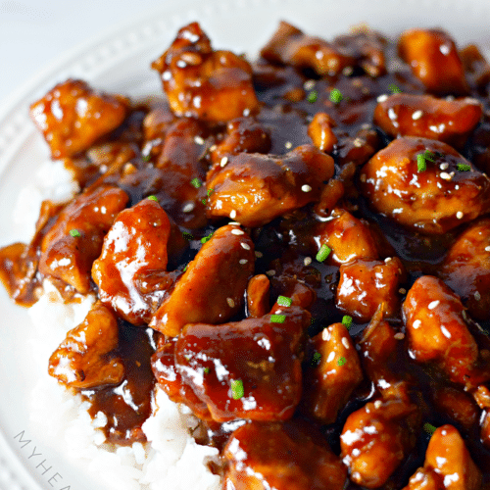

Ingredients:

1 pound Chicken thighs

1/2 teaspoon Roasted garlic

1/2 stick Butter

1/2 cup soy sauce

1/2 cup hoisin sauce

Bourbon (optional)

1/4 - 1/2 cup brown sugar

Preparation:

Season chicken with salt, pepper, and garlic powder; grill until it has nice grill marks. Let rest and cut into strips.

Melt butter in a pan and add in the roasted garlic. Stir in hoisin and soy sauce. Add in bourbon (if using) and brown sugar. Bring to a bubbling simmer, then add in the grilled chicken strips. Cook for about 10 minutes.