Boston Baked Beans – recipe makes 8 servings

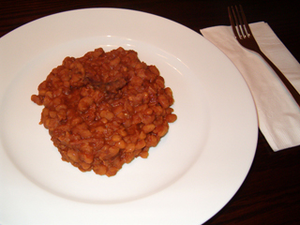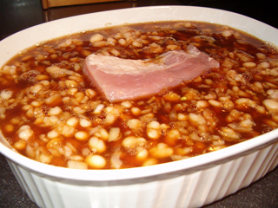

Baked beans had their start with the pilgrims, when cooking on the Sabbath was prohibited. The beans and brown bread recipe were baked the night before, then heated up nice and hot the next day. Today, the beans and bread make a traditional supper on Saturday nights in New England. This recipe is an all-day affair, so make sure you have plenty to do at home so you can stay in and mind these beans as they cook all day long (it's perfect for rainy afternoons)!

Ingredients:
16 ounces (1 pound) dry navy beans
2 quarts cold water
½ teaspoon salt
½ cup molasses
⅓ cup brown sugar
1 teaspoon dry mustard
4 ounces salt pork
1 medium onion, finely chopped

Preparation:
Rinse the beans and discard any bad or deformed ones. Add the beans to the water in a 4-quart pot and soak them overnight. This prepares them for the long cooking process. Alternatively, you may bring them to a boil, simmer them for two minutes, remove them from the heat, cover and let them stand one hour. Also, you may simply drain/rinse four 15-ounce cans navy beans and go from there with the rest of the recipe.

Next, some people recommend discarding the water in which the beans soaked, replacing it with 2 quarts of fresh, cold water (I retain the soak-water to continue the cooking process in, and I've always obtained very good results by doing so - I'm just too afraid to throw out all that good bean flavor with the soak-water!). Add the salt to the beans and water; cover and simmer on low heat at a quiet bubble until the beans are tender, about an hour.

Drain them, reserving the liquid. Measure 2 cups of the liquid (add some fresh water if you come up short of 2 cups). Mix into the reserved two cups of warm bean water the molasses, brown sugar, and mustard. Cut the salt pork in half and score one of the halves. In a food processor, grind/chop or thinly slice the other half.

In a 2½-quart pot or casserole, combine the beans, onion and ground/chopped salt pork. Mix the chopped/ground salt pork up well with the beans. Pour the molasses mixture all over it. Top that then with the scored pork half.

Cover and bake at 300° F. in the oven for at least five, but no more than seven hours (that's right - 5 to 7 hours!). Keep a nice, liquid sauce bubbling in the casserole at all times by adding boiling water, as needed. You shouldn't need to add any until after three hours or so (keep an eye on them).

Check every so often to insure that the sauce is bubbling nicely. Should you neglect the beans long enough that the liquid in the casserole gets baked out of the beans, just take them out of the oven, pour enough boiling water all over the beans just enough to cover them, then stick them back into the oven to continue baking for the remainder of the prescribed time. Keep checking them once in a while and have boiling water at the ready to cover them more, should the sauce start to dry up on you again - you want to have a nice, saucy bubbling going on in the casserole dish at all times until they're finished baking!

