**Avocado Chocolate Mousse - recipe makes 4 servings**

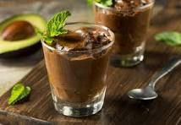

**Ingredients**

* 2 ripe avocados
* 3/4 cup heavy cream
* 1/2 cup dark chocolate chips or broken up chocolate bars
* 1/4 cup honey
* ¼ cup your favorite keto sweetener, like Splenda
* 3 tablespoons unsweetened cocoa powder
* 1 teaspoon vanilla
* 1/4 teaspoon salt
* Shaved chocolate curls and a pinch of ground cayenne, for garnish (optional)

**Directions**

* + Melt the chocolate in the microwave for two minutes while you peel, pit and cut the avocados into small dice.
  + In a food processor, blend all ingredients.
  + Evenly distribute between four dessert dishes, garnish (if desired) and refrigerate 30 minutes before serving.