Applesauce Bread

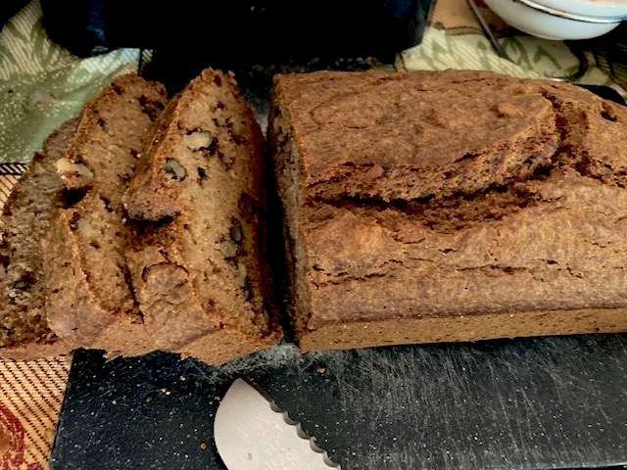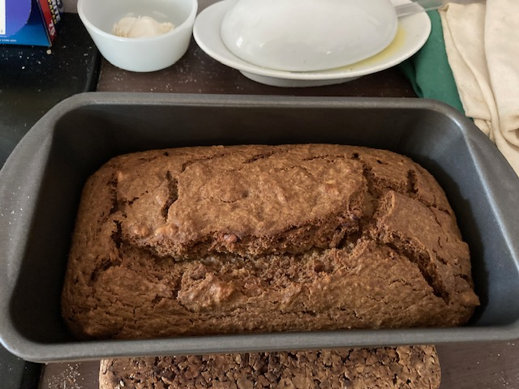

Ingredients:
2 large eggs at room temperature
¾ cups granulated sugar
1 can (15-ounce) or 1½ cups homemade applesauce at room temperature
1 stick (4 oz) unsalted butter, melted and slightly cooled, plus more for the pan
1½ cups all-purpose flour
1½ teaspoons baking soda
½ teaspoon salt
½ teaspoon ground cinnamon
Chopped walnuts (optional, to taste)

Preparation:
Preheat the oven to 350°F. Lightly butter a loaf pan or place paper liners in 12 cupcake or muffin tins.

Beat the eggs and sugar in the bowl until the mixture thickens and turns the color of lemons, 2 - 3 minutes.

Thoroughly whisk in the applesauce and then the butter. If you don’t add in the warm butter little by little, the mixture may appear curdled, but fear not, you did not ruin your batter - just keep on going with the recipe and keep calm.

Dump the flour, baking soda, salt, and cinnamon into the applesauce mixture and combine well with a large spoon or spatula. Add the nuts, if desired, and mix well. Scrape down the sides of the bowl.

Scrape the batter into the prepared loaf pan or, if making muffins, use a 2-ounce ice cream scoop or heaping tablespoon to fill the prepared tins. Bake the bread until golden brown and firm in the center, about 1 hour for loaves and 20 to 25 minutes for muffins.

Let the bread cool in the pans for 5 minutes, then transfer to a wire rack and set aside to cool.

