Apple Tart for Two

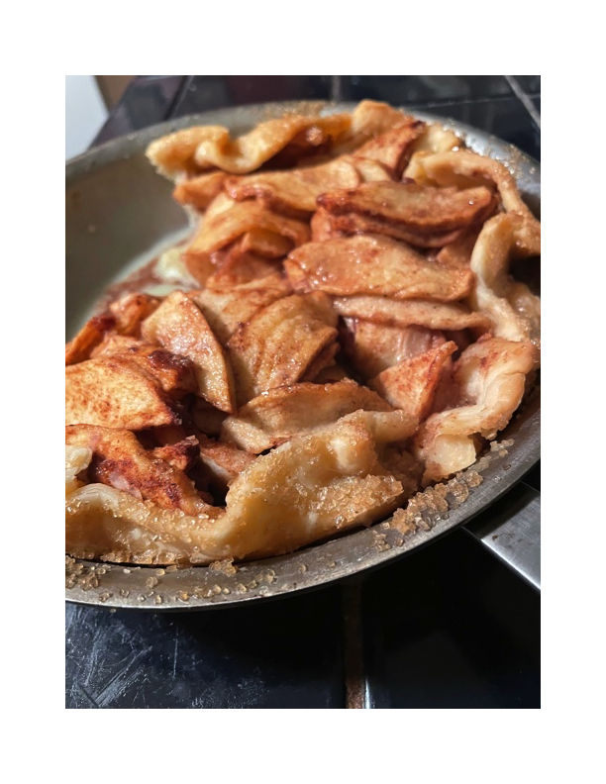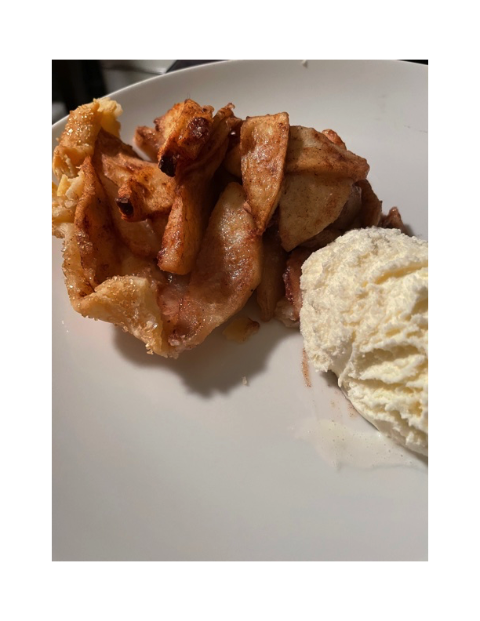

Ingredients:

Make your favorite piecrust – enough to roll out a 10” – 12” disc (see notes below)

4 medium-large apples (any kind), peeled and thinly sliced

6 tablespoons sugar (1 of regular, white granulated sugar and preferably 5 of turbinado, demerara or other kind of large-crystal variety)

1 tablespoon corn starch

1 teaspoon cinnamon, or more to taste

½ teaspoon nutmeg, or more to taste

½ stick butter (4 tablespoons), cut into small cubes

2 tablespoons additional butter, melted for brushing crust

8 ” or 9″ cast iron skillet (see notes below)

1 tablespoon lemon juice

Preparation:

Prepare the apples and keep the cut pieces in a large bowl of water with a squeeze of lemon juice until ready for the pie filling. Heat oven to 400° F. Roll the piecrust out into the skillet. Press it in gently and let the edges hang over the sides. Sprinkle the bottom with a little sugar.

Drain the water thoroughly from the apples. In another large bowl, combine the apples, the granulated, white sugar, cornstarch and spices. Mix it up well until the apples are thoroughly coated. Fill the piecrust with the apple mixture, piling it high in the middle. Gently fold the dough edges uniformly in towards the center. Dot the apples with the butter pats and brush the crust with the melted butter. Sprinkle the large-crystal sugar all over the apples and crust. Bake for 30 – 40 minutes, or until the crust is brown and the sugar has melted. Serve warm (with a dollop of vanilla ice cream on the side, of course).

NOTES:

You may use one disc of store-bought, ready-made piecrust. I also get perfect results by using my 8” All-Clad metal skillet, which I grease thoroughly with butter first.