West-African Bean Fritters – 2 Servings (4 fritters per serving)

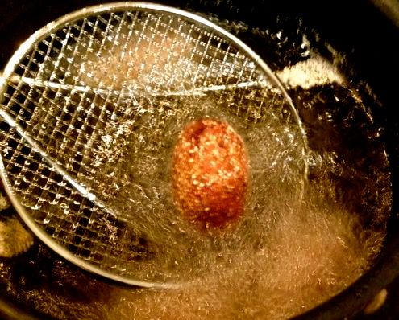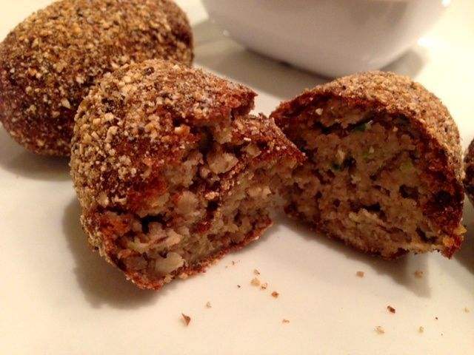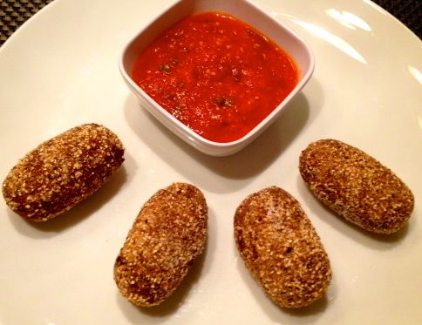

Reminiscent of southern hushpuppies, this is a unique way to usher in the New Year with the good luck brought by eating black-eyed peas, as we do down south in the U.S.A.!

Ingredients:
1, 15-ounce can black-eyed peas, rinsed and drained
1 large egg
2 tablespoons (1 ounce) chopped, green onion/scallion (or any type onion)
1” long piece fresh ginger, chopped (or 1 - 1½ teaspoons ground ginger will do)
1 small Serrano chili, minced
½ teaspoon salt
¼ cup plain, dry bread crumbs
¼ cup cornmeal
Vegetable oil, for frying
Ginger-Tomato Dipping Sauce (recipe follows below)

Preparation:
Process black-eyed peas, egg, onion, ginger, jalapeño chili and salt in food processor or blender until smooth. Transfer mixture to a medium bowl. Stir in breadcrumbs.

To shape fritters, divide black-eyed-pea mixture in half, then divide each half equally into quarters, then divide each quarter again so that you have 8 equal-sized pieces total. Roll them into ovals, coat lightly in cornmeal.

Heat oil in a large saucepan at a depth of 2” to 350° F. Fry fritters, 4 at a time, until browned, about 4 - 5 minutes. Season with a sprinkle of salt and keep warm on a wire wrack set on a parchment-lined baking sheet in a 200° F. oven until ready to serve.

Ginger-Tomato Dipping Sauce
½ can (14½ ounce size) diced tomatoes, undrained
2 cloves garlic, chopped
2 tablespoons (1 ounce) onion, chopped
1 jalapeño chili, chopped
1 tablespoon (½ ounce) chopped gingerroot, or 2 teaspoons ground ginger
½ teaspoon salt
1 tablespoon vegetable oil

Process all ingredients, except oil, in food processor or blender until smooth. Sauté sauce in oil in small skillet until thickened. Makes about 1 cup.

