Tagine of Chicken, Preserved Lemon, & Olives - a Moroccan favorite!

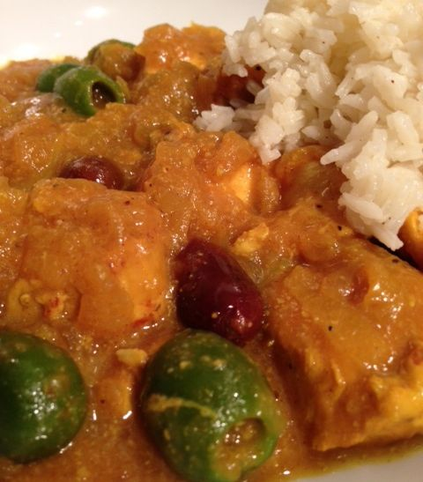 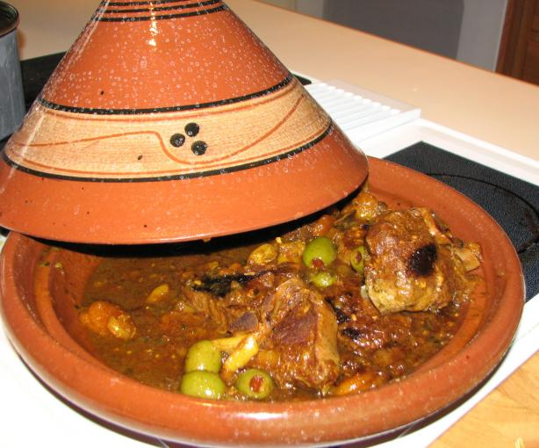 Recipe serves two.

INGREDIENTS:
2 - 4 cloves garlic, minced
olive oil, for pan-frying chicken and mixing marinade
½ lb. chicken, cut into serving-sized pieces
¼ teaspoon black pepper
1/8 teaspoon ground ginger
1 pinch saffron
½ teaspoon cumin (optional)
½ teaspoon turmeric (optional)
1 cinnamon stick, or 1 - 2 pinches ground cinnamon (optional)
½ teaspoon ground coriander (optional)
1 onion, finely chopped
1 cup chicken broth, or 1 cup chicken stock (or water)
½ - 1 cup olives
1 preserved lemon, cut into slices
salt, to taste – wait until after the lemon is added as it is quite salty to begin with!

PREPARATION:
Mix the garlic, some black pepper, and a spoonful of oil. Rub the chicken with the mixture and set aside for a few hours in the fridge (I put it in a quart Ziploc).

Heat the oil in a large saucepan (or tagine cooking pot, if you have one). Fry the chicken until all sides are browned. Add onions, stir-fry over medium-high heat for a few minutes. Add spices - black pepper, ginger, and saffron are most typical.

Add in the chicken broth/stock, or water and bring to boil. Reduce heat, cover, but leave a crack for steam to escape. Simmer over low heat for thirty minutes or more, depending on the size of your chicken pieces, until chicken is cooked through.

Stir in the olives, preserved lemon and salt. Uncover, increase the heat to medium and continue to simmer until sauce is nicely thickened, 15 minutes more.

They serve this over steamed couscous or rice with French-fried potatoes in Morocco!

