Sticky Roasted Ras El Hanout Chicken, Moroccan Style (Poulet à la Marinade de Rass El Hanout, style marocain)!

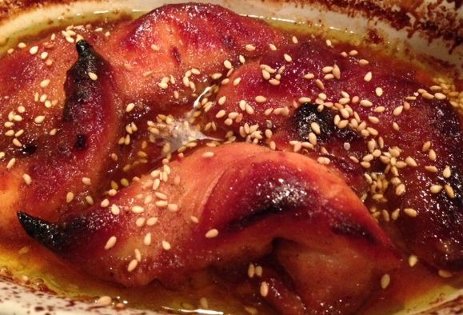 جْنيحاتْ الدّْجاجْ مْعَسّْلينْ

Ras el Hanout sauce creates a sticky glaze while cooking in the hot oven and, when cooked, the chicken pieces turn out so beautifully brown and crispy! They taste delicious and can be served with all types of vegetables, couscous, rice, etc. The excess sauce goes perfectly with side dishes. Recipe serves 2.

Ingredients:
about ¾ lb. chicken
1 teaspoon Ras el Hanout, Moroccan spice blend
salt
6 teaspoons honey
6 teaspoons olive oil
1 tablespoon brown sugar
toasted sesame seeds or flaked almonds
Préparation:
Preheat oven to 400° F.
Combine Ras el Hanout, salt, honey, olive oil and brown sugar in medium bowl until well mixed. For sweeter version, double the amount of brown sugar and honey set down in this recipe.

Rinse chicken pieces, pat dry with paper towels. Place is a Ziploc freezer bag and pour over marinade, coating chicken well. Seal bag and refrigerate, turning occasionally, for at least 2 hours, but overnight is best.
Place the chicken pieces in a suitably sized, shallow baking dish. Spread the sauce over the base. Roast uncovered for 35 to 40 minutes until golden brown. Sprinkle toasted sesame seeds or flaked almonds on the chicken and serve!

