Mauritian Salade Chou Chou (pronounced “shoo-shoo”). Recipe serves 2.

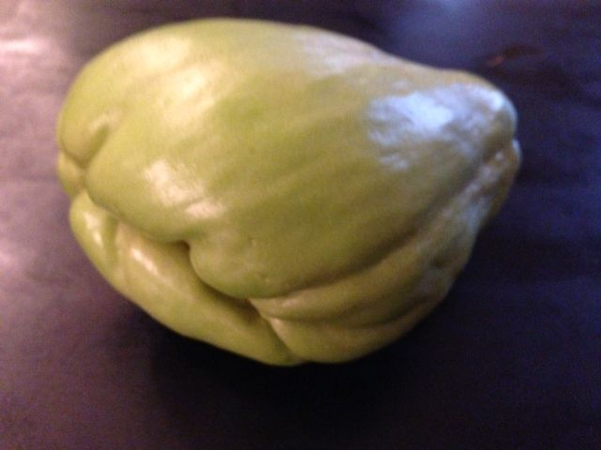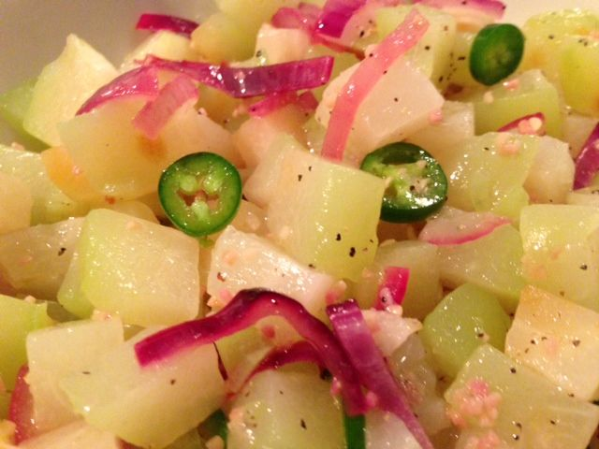

Ingredients:
1 larger sized choko/chayote squash/mirliton
1 tablespoon white-wine vinegar
2 tablespoons extra virgin olive oil
1 big clove (or two small) garlic, minced
1 small onion (sweet-red works great), peeled, quartered and finely sliced
1 fat Serrano chili, finely sliced into little rings (leave the seeds in you like it hot!)
Freshly ground, black pepper, to taste
1 teaspoon salt for the boil-water and more to season the salad

Preparation:
Peel the chayote as you would a potato, remove the tough inner seed pocket and chop into 1” cubes. Boil the cubes in salted water until tender for 15 minutes. Strain into a sieve and run under cold water a minute. Let the chayote drain thoroughly.

I like to microwave the sliced onion and minced garlic in a bowl on high for 30 seconds to blanch them and take some of the raw bite out of them.

Toss together the choko chunks with the sliced chilies, onions and garlic. Whisk the oil and vinegar with salt and pepper to taste until the mixture is milky. Pour it over the vegetables and carefully toss it all together. Cover and chill for half an hour in the fridge.

Notes:
This salad makes a good addition to any meal as a side dish – prepare it before making your main dish! I let the chayote marinate in the dressing at least an half-hour in the fridge before serving. Being from an African island in the Indian Ocean, my guess is that this dish can certainly be served without being chilled first!

