Sudanese Mince-Stuffed Tomatoes (recipe serves 2).
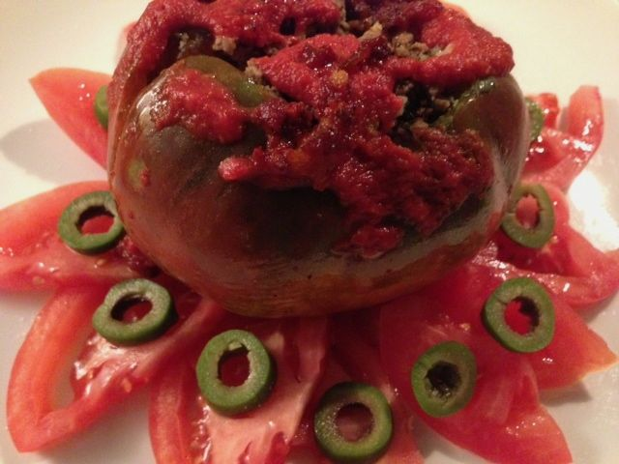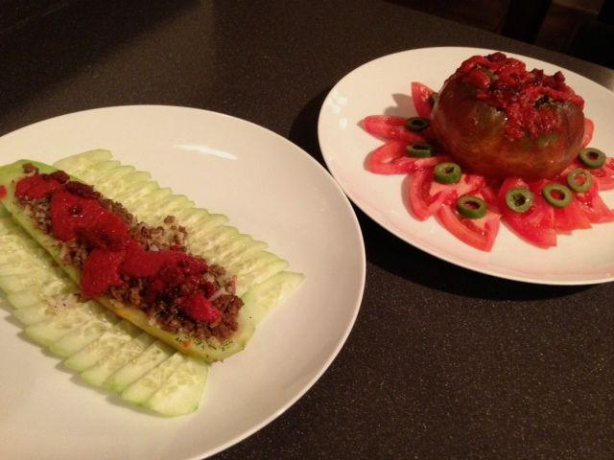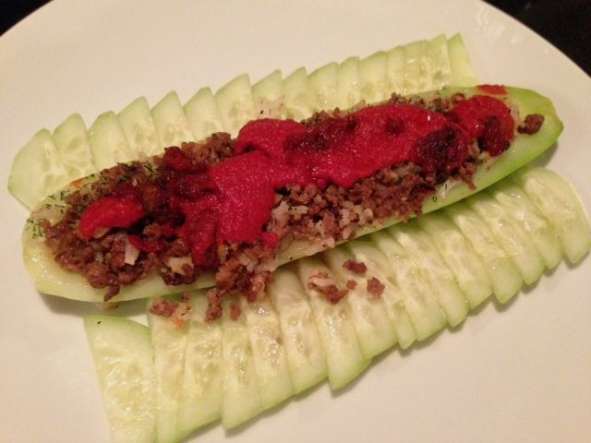
Called “maschi” (pronounced “mawshy”) in Sudan, these are also made by stuffing cucumbers. The cucumbers are peeled and made into little boats by cutting lengthwise, scooping the seeds out, then filling and finishing as below. You may also use eggplants. Peel small eggplants, remove the tops, scoop out interiors and proceed in the same manner.

Ingredients:

For the Maschi
½ pound ground beef – I use lean sirloin or chuck
2 large tomatoes and/or medium cucumbers, peeled, seeds scooped out (see note).
½ teaspoon salt
¼ teaspoon ground, black pepper
1 clove garlic, minced - or you may use ½ teaspoon granulated garlic powder
2 tablespoons fresh dill weed, chopped (or ½ teaspoon dried dill)
1 tablespoon olive, peanut or other vegetable oil
1 tablespoon butter
¼ cup cooked rice
¼ cup (2 ounces) green olives, pitted and sliced for garnish

For the Sauce
3 tablespoons tomato paste, thinned with 3 tablespoons water
¼ teaspoon salt
¼ teaspoon cinnamon
¼ teaspoon granulated garlic powder

Preparation:
Heat the oil in a large pot over medium heat. In it, brown the beef with ½ teaspoon salt, ¼ teaspoon pepper, the fresh garlic or substituted garlic powder and the dill. Drain fat and add ¼ cup cooked rice; blend well.

Cut a circular incision around the top of each tomato so that you can remove the top and scoop out the interior of the fruit enough to fill with half of the meat and rice. Prepare cucumbers, as described above by making “boats” out of each peeled half and filling each with the seasoned meat-rice mixture.

Melt 1 tablespoon butter and 1 tablespoon vegetable oil in the pot. Sauté the filled cucumbers and the stuffed tomatoes carefully in the fat, rolling the tomatoes gently a little until they become dark red all around.

Prepare sauce by combining sauce ingredients in a small cup or bowl. Pour it evenly over the tomatoes and/or cucumbers, cover and simmer gently over low flame for 10 to 15 minutes, until sauce is cooked.

Remove carefully to round platters. The cucumber dish is garnished with fresh cucumber slices and the eggplant with tomato and cucumber slices overlapping all around the edge. Surround the stuffed tomatoes with raw tomatoes cut in thick slices. Top each slice with sliced green olives.

Note: The filling is enough for two large tomatoes, or one large cucumber cut in half, or, alternatively, one large tomato and one large cucumber – it is enough to fill a large tomato and one half of a large cucumber, then you use the second half of the cucumber as the garnish. I always use a smaller tomato for the garnish slices that accompany the stuffed tomato.

