FRIED PLANTAINS

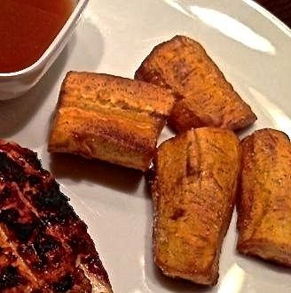
These are eaten all over the continent and will make a very authentic addition to your African dinner, as well as add to the presentation.
Cut four green plantains, or plantains with very little yellow color, in half lengthwise and then crosswise into six uniform pieces (I like to cut them in half, then cut each half into three plank-sections).
Sauté them quickly in a quarter of an inch of hot oil in a sauté pan. Use green bananas if plantains are not available.

