Egyptian “Chili” (Foule) – recipe serves 2.

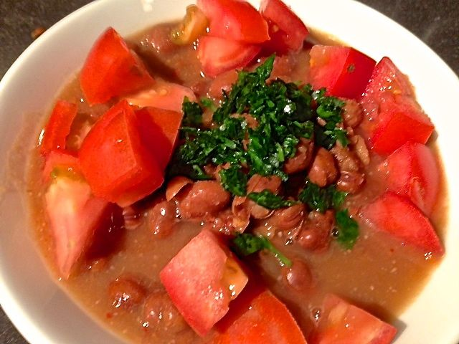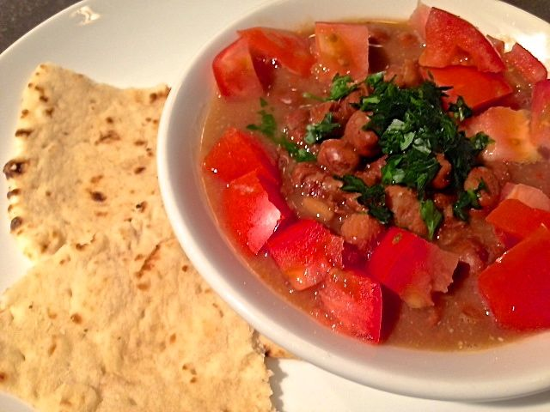

Ingredients:
2, 15½-ounce cans fava beans (ful medammes), drained and rinsed
½ cup water, vegetable or chicken broth
2 cloves garlic, pressed
½ teaspoon cumin
2 tablespoons lemon juice (the juice of 1 lemon)
Salt
Crushed, red-pepper flakes (as much as you can stand)
1 medium-sized tomato, chopped
Olive oil
2 tablespoons fresh parsley, finely chopped

Preparation:
Heat the can of beans (including liquid) with the water or broth gently in large saucepan until boiling. Simmer on low for 10 minutes to heat through. (Alternatively, heat beans in microwave.)

In a small bowl, mix the pressed garlic with the cumin, lemon juice, and salt (½ teaspoon salt with canned beans, more for dried).

Mash about ¼ of the beans with a wooden spoon, pestle or potato masher, leaving most beans intact. Add the lemon juice mixture and gently stir in. Taste and add more salt or lemon juice if necessary.

Transfer the foule to shallow serving dishes. Top with the chopped tomato, a generous drizzle of olive oil and the chopped parsley.

Serve warm or at room temperature with sweet tea and fresh Arabic bread. Optional additions on the side: extra lemon wedges, chopped onion, sliced cucumber, chopped green pepper, fresh mint, crumbled feta cheese and/or one hard-cooked egg for each person.

