Kenyan Chicken Tika for Two
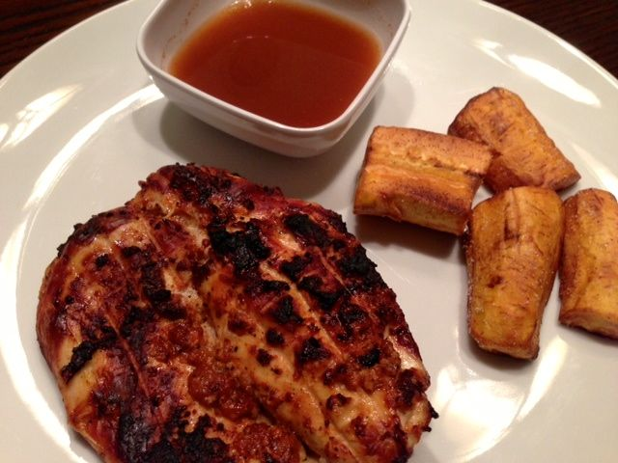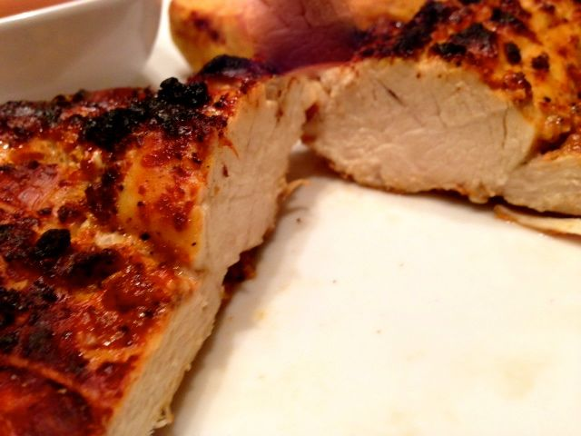
Ingredients:

For the Chicken
½ pound chicken (skinless breast meat is good)
1 teaspoon tomato paste
1 teaspoon curry powder
1 - 2 cloves garlic (more or less), finely minced
4½ teaspoons peanut oil
¼ teaspoon salt
½ teaspoon ground, black pepper

Ingredients for the Sauce
½ cup tamarind juice/nector (if unavailable, use 1 cup cola, like Coke or Pepsi, simmered down to half volume over medium heat)
½ teaspoon salt
½ teaspoon cayenne, or to taste
½ teaspoon sugar, or to taste

Combine tomato paste, curry powder, garlic, salt, pepper, and oil. Rub the chicken with this mixture and leave it for at least 1 hour (up to 6 hours, or overnight is okay) for the flavor to penetrate the meat.

Grill or roast the chicken until nicely browned and tender. I line a baking sheet with foil and set a greased, wire rack on it to broil the chicken in the oven.

Combine the sauce ingredients and serve on the side. Spoon sauce over the chicken, to taste, at the table.

