Slow-Cooker Ham & Beans (recipe makes 4 servings)

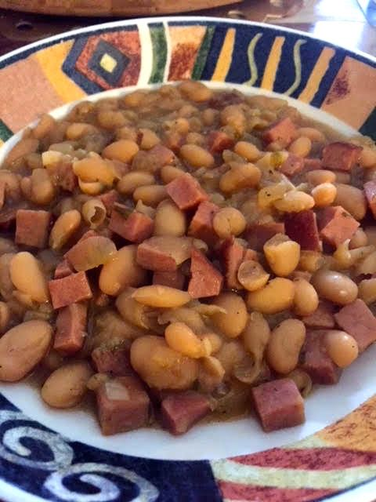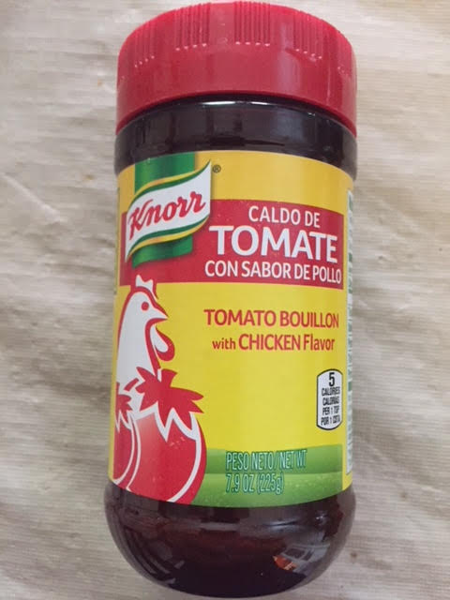

Ingredients:
- 2, 15-ounce cans great northern white beans, drained and rinsed well
- 3 – 4 garlic cloves, peeled and minced
- 1 small sweet onion, chopped into pieces the same size as the beans
- ⅛ teaspoon regular table salt
- ¼ teaspoon black pepper, more to taste
- 1 tablespoon chopped parsley
- 1 tablespoon Knorr brand tomato bouillon with chicken flavor
- ⅛ teaspoon ground cloves
- ½ pound smoked ham or 1 ham hock
- 1 cup water or 1 cup broth

Preparation:
Mix all ingredients well in a medium-sized slow cooker and cook on “Low” 8 hours or “High” 4 hours.

If it’s a little too soupy after the slow-cooker time, just remove to a large saucepan on the stove, bring to a boil, reduce the heat to medium and let simmer nice and bubbly until reduced and thickened to your liking.

