Mongolian Beef in a Slow Cooker for Two

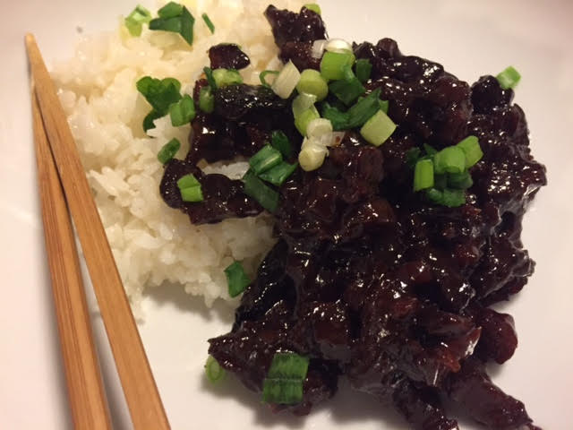

Rich, seasoned, sweet, sticky and delicious – this slow-cooker recipe with such succulent and crispy beef is a knock out!

Ingredients:
1 flank steak, about ¾ of a pound, thinly sliced (I have the butcher do it)
½ cup flour
3 cloves garlic, minced
¼ cup soy sauce
¼ cup beef broth
¼ cup white, granulated sugar
1½ teaspoons molasses
1 teaspoon minced ginger
¼ teaspoon salt
¼ teaspoon pepper
2 green onions/scallions, both white and green parts, sliced

Preparation:
Combine thoroughly the garlic, soy sauce, beef broth, sugar, molasses, and ginger in small bowl or measuring cup and then pour the mixture into a medium-sized slow cooker.

Season the flour with the salt and pepper. Toss the strips of flank steak in the flour (I just shake them all together in a small paper bag), shake off excess, and place in the slow cooker along with the sauce. Once all the flank steak has been coated and placed in the slow cooker, stir everything together to combine.

Cover with the lid, set to low, and cook for 8 hours (4 hours on the high setting). Garnish with the sliced scallions and serve with steamed jasmine rice.

