Mexican Chicken Soup in the Slow Cooker for Two

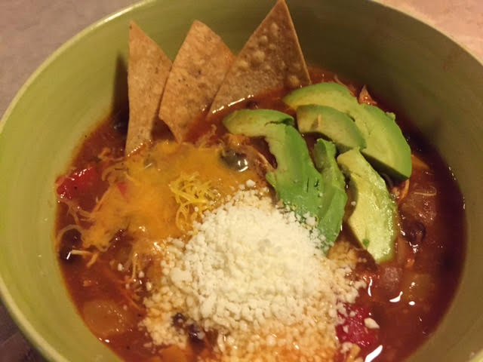

Ingredients:
1 boneless, skinless chicken breast
1 teaspoon chili powder
½ teaspoon ground cumin
Salt and ground, black pepper, to taste
1 small onion, peeled and finely chopped
1 small or ½ a red bell pepper, seeded and finely chopped
1 small or ½ a yellow bell pepper, seeded and finely chopped
2 – 4 cloves garlic, minced
1 can (14 ounces) whole or diced tomatoes and their juice
1 can Rotel brand diced tomatoes and green chilies
1½ cups chicken broth (more if you like the soup thin)
4 tablespoons tomato paste
Chipotle chili pepper in adobo, to taste
1 can black beans, drained and rinsed
Juice of 1 lime (about 4 tablespoons)
Crushed tortilla chips, sour cream, avocado, cilantro leaves and/or grated cheese, to garnish the soup before serving

Preparation:
Place the chicken in the slow cooker and add in all the remaining ingredients. Stir, cover the slow cooker, and cook on high for 4 hours or 8 hours on low.
By the end of the cooking time, the chicken will be falling-apart tender. Using 2 forks, shred the chicken in the pot and check the seasoning. Serve the soup hot topped with your favorite Mexican garnishes.

