Slow Cooker Mac n’ Cheese – recipe makes about a dozen servings

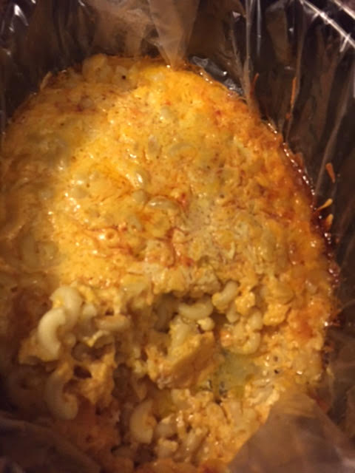

Ingredients:
Cooking spray, to grease the inside of the slow cooker (I use Reynolds liners)
8 ounces elbow macaroni, cooked according to package directions
1, 12-ounce can evaporated milk
1½ cups whole milk
¼ cup (½ stick ) of butter, melted
1 teaspoon salt
Dash of pepper
2 large eggs, beaten
2, 8-ounce bricks sharp Cheddar cheese, grated (about 5 cups)
1 teaspoon paprika

Preparation:
In a large 4-quart slow cooker sprayed with cooking spray or lined with Reynolds plastic slow-cooker bags, mix the macaroni, evaporated milk, milk, butter, salt, pepper, eggs and all but ½ cup of the grated cheese. Sprinkle the reserved cheese over the top of the mixture and then sprinkle with paprika. Cover and cook on low heat for 3 hours and 15 minutes. Turn off the slow cooker, stir the mixture and serve hot.

Note:
If you don't have a slow cooker, grease a 9” x 13” x 2” pan with butter, add the mixture and bake at 350° F. for 50 minutes.

