Chicken Tostadas for Two

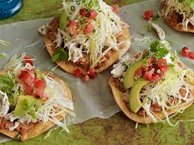

Ingredients:
1 pound chicken thighs, boneless, skinless
¼ onion, small diced
3 cloves garlic, minced
¾ teaspoon dried oregano, preferably the Mexican variety
Zest and juice of 1 lime
4½ teaspoons Frank’s “Red Hot” sauce
⅛ teaspoon ground cumin
1 teaspoon onion powder
1 teaspoon garlic powder
¼ teaspoon ground cayenne
1½ teaspoons dark chili powder
¼ teaspoon table salt (not kosher or sea salt)
4 tostadas (deep-fried, corn tortillas), for serving with garnishes of choice, like crumbled Mexican white cheese, refried beans, diced tomatoes, chopped cilantro, avocado slices, shredded lettuce or cabbage

Preparation:
In a smaller-sized slow cooker, add in all ingredients, except the tortillas. Mix well. Be sure to rub the spices into the chicken. Cook on low for 4 hours.

Using 2 forks, shred chicken in the slow cooker. Mix well. Serve on the deep-fried, corn tortillas along with your favorite toppings.

