Slow-Cooker Beef, Tater Tots and Green Bean Casserole

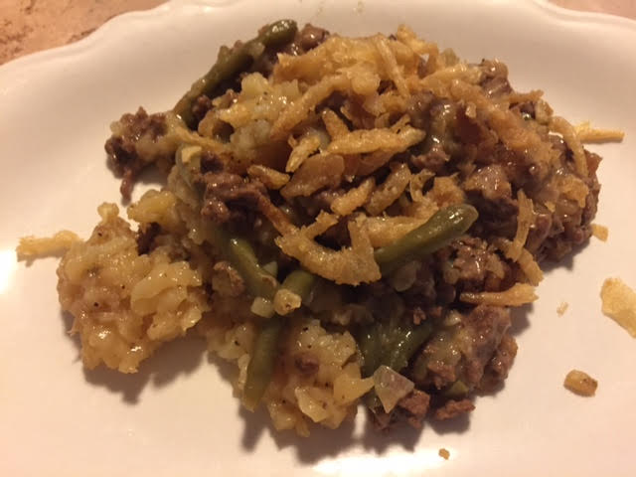

I know it sounds odd to put tater tots in a slow cooker, but they come out tasting deliciously like a cross between mashed potatoes and baked potatoes in this recipe.

Ingredients:
1 pound ground beef
1 can cream of celery soup
1 white onion, chopped
½ teaspoon salt
¼ teaspoon pepper
⅓ cup half and half or cream
1 pound frozen tater tots
½ pound frozen green beans
1 can French's (or other brand) fried onions

Preparation:
Sauté the beef with the chopped onions over medium heat until the beef has browned and then drain. Pour the soup and the half and half or cream over the beef and stir with a wooden spoon until well mixed. Season with salt and pepper.

Lightly grease your slow cooker (I use Reynolds slow-cooker liners) before layering the tater tots and the green beans in the bottom of the pot. Pour the beef mixture over the top, ensuring that the vegetables are completely covered, then sprinkle half the French’s onions over the top; cook on low for 6 hours.

Sprinkle the rest of the fried onions equally over the tops of each serving.

