Latin-American Barbacoa (recipe serves 4)

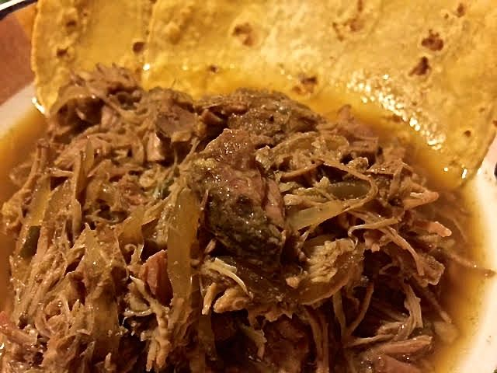

We get the English word barbeque from this rich and succulent Latin-American specialty that is served over rice, or as a filling for burritos and tacos.

Ingredients:
1 pound beef chuck roast and/or pork shoulder (a/k/a pork “butt”), large cubed
¼ white onion, sliced
¼ red onion, sliced
1 jalapeno pepper, diced
¾ cup beef broth
1 – 2 cloves garlic, minced
4½ teaspoons ground cumin
1 teaspoon dried oregano
1 whole clove
Juice of 1 lime (about 2 tablespoons)
Salt and ground black pepper, to taste

Preparation:
Place everything in a smaller sized slow cooker and stir to fully incorporate all ingredients.

Place lid on slow cooker and set to low. Cook for 5 hours, or until meat is tender enough to shred.

Using two forks, shred meat right inside the slow cooker. Stir to incorporate shredded meat completely with juices from the slow cooker. Place lid back on, and cook for another 10 minutes.

