Tuscan Beef Sauce for Two

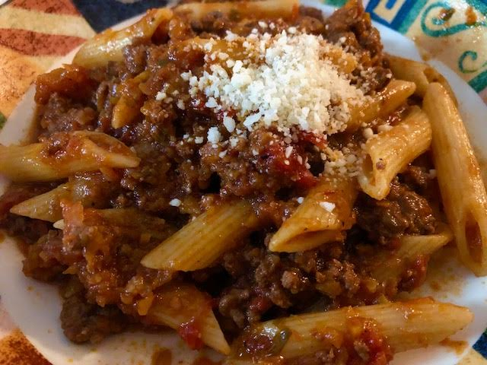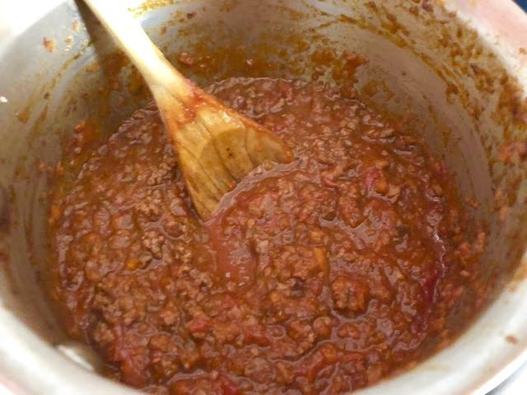

This simple pasta sauce is the go-to for feeding hungry Tuscan ranchers and farmhands more often than not. I remember being served something almost exactly like this by Italian-army mess personnel when I was stationed on temporary duty in the northeast of Italy with an Italian army intelligence unit when I was a U.S. Army soldier way back in the ‘80s. I add both wine and beef broth to mine.

Ingredients:
½ pound ground beef – ground pork and/or turkey make good substitutes
1 14½ -ounce can San Marzano Italian tomatoes, crushed by hand
1 rib celery, chopped very fine
1 small onion, chopped very fine
1 carrot, chopped very fine
½ cup good red wine (the kind you would drink), and/or beef broth
4 ounces pasta (2 ounces for each adult serving is recommended)
Salt and ground, black pepper, to taste

Preparation:
Chop the vegetables very finely (I put them in a food processor) and sauté on medium-high heat in olive oil until wilted and translucent. Crumble in the meat and continue to cook on medium-high heat until cooked through, stirring frequently.

Deglaze the pot with the wine/broth and let it evaporate, uncovered. Add the tomatoes with their juices, and season with salt and pepper to taste; bring to a boil, then simmer the sauce, partially covered, for up to 2-3 hours on very low heat. If you don’t have that much time, 30-45 minutes will be fine. If it becomes too dry and reduced while simmering, just add more broth or water (but not wine).

Cook the pasta according to package directions right before serving. Rigatoni or penne are the best choices.

Drain the pasta and stir it well with the sauce. Let sit for a few minutes on very low heat before serving so the pasta absorbs the flavor of the sauce. Top with grated cheese and/or crushed-red pepper flakes, if you like.

