Spaghetti Casserole for Two

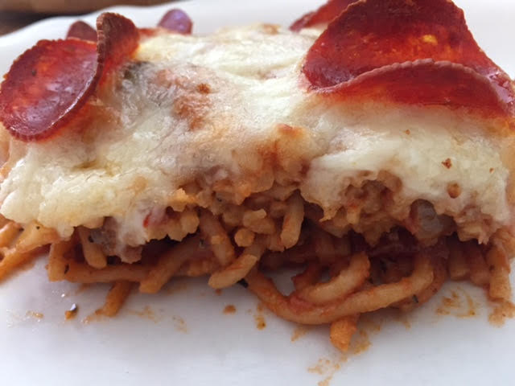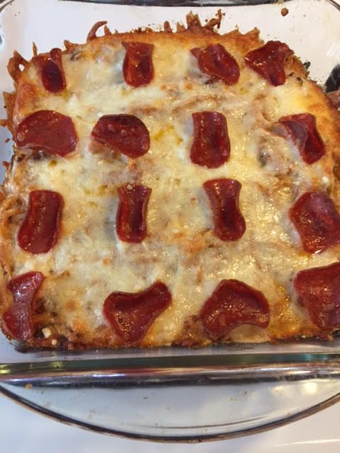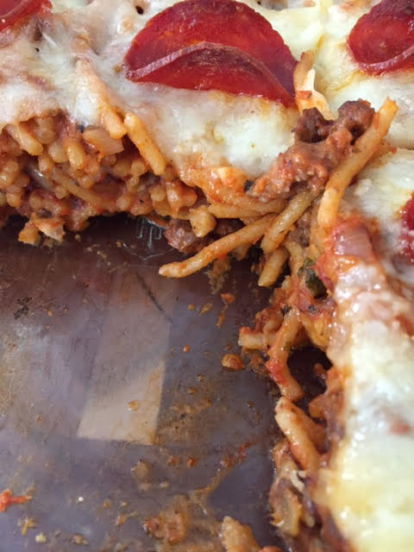

This easy, Sunday “gravy” is as Italian-American as they come!

Ingredients:
1 teaspoon olive oil
6 ounces ground beef, pork and/or Italian sausage
1 small onion, small diced
4 cloves garlic, minced
¾ teaspoon dried oregano
¾ teaspoon dried basil
1½ teaspoons tomato paste (You can replace the tomato paste, sauce and diced
1 cup canned tomato sauce tomatoes with 12 ounces of jarred pasta sauce.)
½ cup canned diced tomatoes
¼ teaspoon red pepper flakes
¾ teaspoon salt
4 ounces dry spaghetti
1 tablespoon cream cheese
½ - ¾ cup shredded mozzarella cheese
¼ - ½ cup grated Parmesan cheese

Preparation:
Preheat oven to 375° F.

Add olive oil to a pot on medium-high heat. When oil is hot, add the meat, onions, garlic, oregano and basil. Brown the meat and break up into crumbles. Drain fat. Stir in tomato paste and cook for 2 minutes. Add tomato puree, diced tomatoes, red pepper flakes and salt. Simmer for 10 minutes on medium-low heat.

Cook spaghetti according to package. Strain out water.

Add cooked spaghetti into pot with tomato sauce. Stir in cream cheese. Pour into an 8” x 8” casserole dish. Top with mozzarella and Parmesan cheeses. I top it with some pepperoni slices, too! Bake uncovered for 20 minutes, or until cheese is browned.

