Pork and Broccoli Rabe Cheesesteak Sandwiches for Two

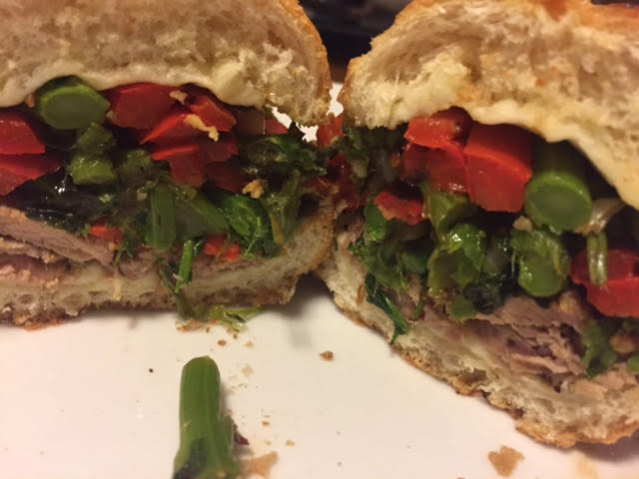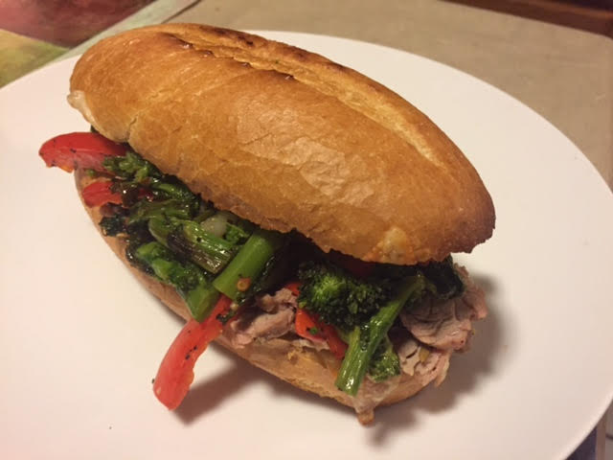

Ingredients:
½ pound pork tenderloin, trimmed of silver skin
3 tablespoons olive oil
Salt and pepper
1½ teaspoons rosemary
1½ teaspoons whole fennel seeds
1 supermarket bunch broccoli rabe, leaves trimmed off and cut into 1” pieces
4 garlic cloves, minced
½ teaspoon crushed red-pepper flakes
1 long red bell pepper, stemmed, seeded, and sliced thinly
2, 6” Italian sub rolls, split lengthwise
4 ounces sliced provolone cheese
1 tablespoon red wine vinegar

Preparation:
Preheat oven to 450° F. Rub tenderloin with 1 tablespoon oil, season with salt and pepper, then sprinkle with the rosemary and fennel seeds. Place on 1 side of foil-lined baking sheet and roast for 10 minutes.

Toss the broccoli rabe with 1 tablespoon oil, the garlic, and pepper flakes in bowl. In separate bowl, toss the bell peppers with 1½ teaspoons oil and season with salt and pepper. Remove sheet from oven and flip pork. Spread broccoli rabe and bell peppers on hot sheet next to pork. Continue to roast until pork reaches 145° F. and broccoli rabe and bell peppers are browned, about 20 minutes.

Remove sheet from oven. Transfer pork to cutting board, tent loosely with aluminum foil, and let rest for 5 minutes. Transfer vegetables to bowl and cover with foil to keep warm. Wipe sheet clean with paper towels, lay split rolls open on sheet and top each evenly with cheese. Bake rolls until the bread is lightly toasted and the cheese is melted, about 5 minutes.

Slice pork as thinly as possible, transfer to clean bowl, then toss with 1½ teaspoons oil and the vinegar. Nestle the pork slices, broccoli, and bell peppers into warm rolls and serve.

