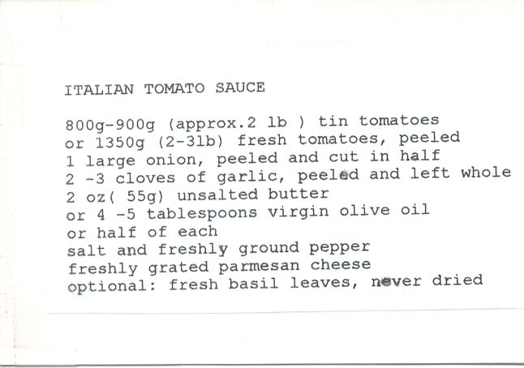
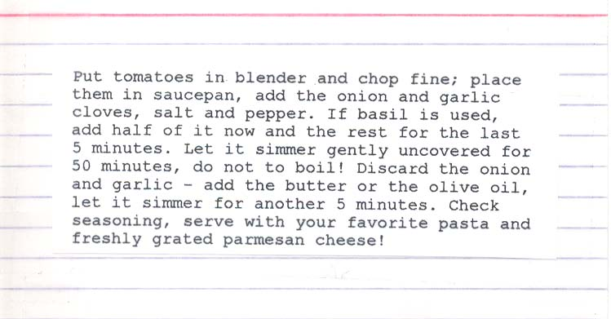

This was a recipe that I picked up from an Italian-Army cook friend, Sergeant Geraldo Natale, when I was stationed in northern Italy in the Veneto (where Venice is) on temporary assignment in the ‘80s. I didn’t speak Italian, he didn’t speak English, but we both spoke French very well. Consequently, we ended up serving as the interpreters for our two military units (it was a great experience, except for the grappa-liquor hangover)!

This recipe makes enough to divide evenly between three, quart-sized freezer bags with two servings each, so double it to get six freezer bags’ worth!

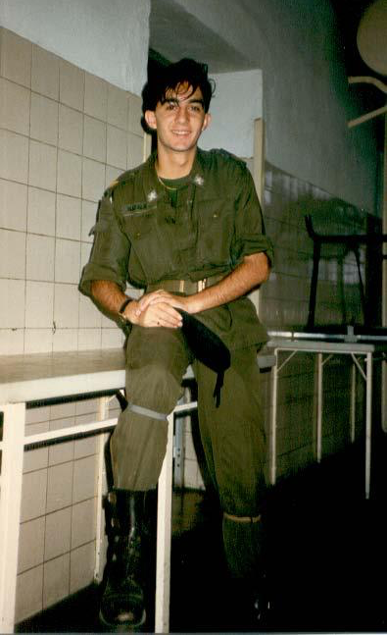

Sergente Natale – such a handsome young devil then!

