Herb-Roasted Fish for Two

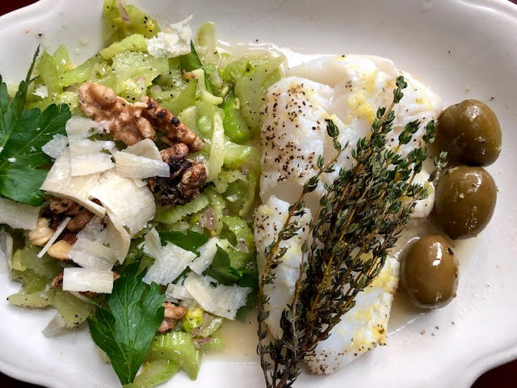

Ingredients:
2, 6 – 8 ounce filets white fish, like cod or Haddock
4 – 6 big, green cerignola olives
Zest of 1 lemon
2 tablespoons lemon juice (the juice of 1 lemon)
4 – 6 sprigs fresh thyme
2 tablespoons olive oil
1 teaspoon salt, divided in half
½ teaspoon ground, black pepper, divided in half
1 egg
Preparation:
Preheat oven to 400° F.
Place the fish fillets at the top of a baking-sheet sized piece of parchment paper (they sell boxes of pre-cut/sized baking-sheet pieces of parchment in the supermarkets now). Sprinkle each piece of fish with ¾ teaspoon salt, ¼ teaspoon pepper, 2 tablespoons lemon juice, 1 tablespoon olive oil, half the lemon zest and, a few sprigs of fresh thyme laid over each fillet; lay the olives next to the fillets on the paper.

Make an egg wash to seal the edges of the parchment paper – crack the egg in a small bowl and whisk it well with a tablespoon of water. Brush along the edges of the parchment and fold the parchment really well all around the fish (try to make an envelope of sorts for the fish out of it). Bake at 400° F. for 15 minutes. Serve with a nice side salad.

