Ground meat and Orecchiette Pasta For Two

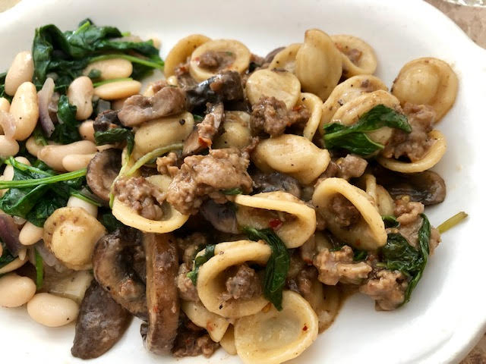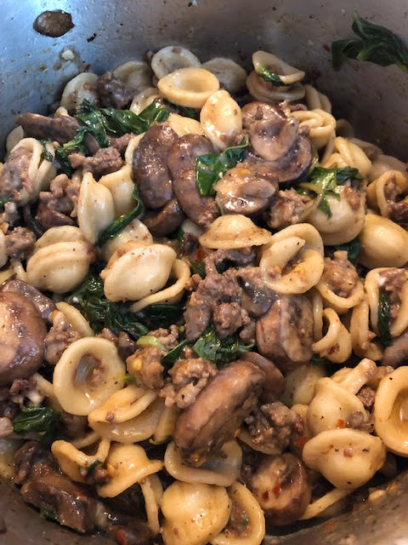

This is a very simple, Italian-American dish from the area of Pittsburgh, PA that is very flexible – use any kind of ground meat on hand!
Ingredients:
4 ounces orecchiette pasta
½ pound ground meat
½ teaspoon salt, or to taste
¼ teaspoon ground, black pepper
¼ teaspoon granulated garlic powder
¼ teaspoon crushed red-chili flakes
½ cup broth/stock (any kind will do)
8 ounces sliced mushrooms
2 – 3 ounces fresh basil, torn
½ cup grated Parmesan cheese

Preparation:
Boil 4 ounces of orecchiette pasta. This pasta is amazing – it actually cradles the meat-mushroom sauce for you as you eat it!
Brown half a pound of ground beef, lamb, ground chicken or sausage meat. Season with salt, ground black pepper, garlic powder and a little bit of crushed red chili flakes. Add sliced mushrooms. Add ½ cup beef, chicken or vegetable broth. Add chopped basil. Add in the pasta. Warm through, then add grated Parmesan. Adjust sauciness to taste with more broth, or even some of the hot pasta water.

