Chicken Piccata for Two

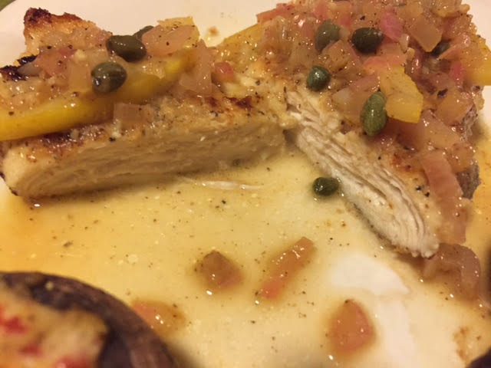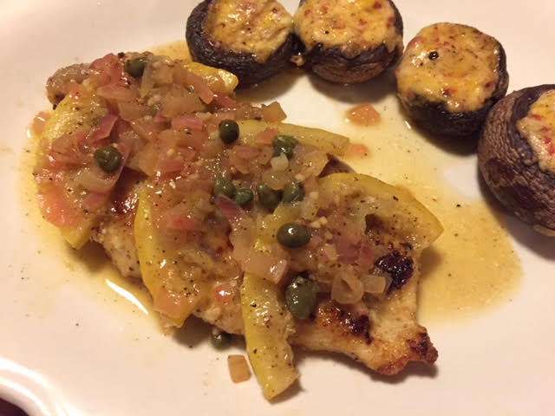

Ingredients:
- 1 large lemon, sliced in half – one half sliced thinly, other half juiced (4 tablespoons)
- 2 boneless, skinless chicken breast cutlets, rinsed and dried thoroughly
- Salt and ground black pepper, to taste
- ¼ cup all-purpose flour
- 2 tablespoons olive oil
- ½ a shallot or very small shallot, minced
- 1 clove garlic, minced
- ½ cup chicken stock or broth
- 1 tablespoon small capers, drained
- 4½ teaspoons unsalted butter, softened
1 tablespoon minced fresh parsley leaves

Preparation:
- Sprinkle both sides of cutlets generously with salt and pepper. Dredge cutlets in the flour (I shake them up in a paper bag).

- Heat a heavy-bottomed 12-inch skillet over medium-high heat until hot, about 2 minutes; add a tablespoon of oil; swirl pan to coat. Lay the chicken cutlets in and sauté, without moving them, until lightly browned on first side, 2 to 2½ minutes. Turn cutlets and cook until second side is lightly browned, 2 to 2½ minutes. Remove cutlets from the skillet to serving plates and let rest while you make the sauce.

Add shallot and garlic to empty skillet and sauté until fragrant. Add the stock/broth and lemon slices, increase heat to high and scrape loose any browned bits. Simmer until liquid reduces to about 5 or 6 tablespoons, about 4 minutes. Add lemon juice and capers and simmer until sauce reduces again to 5 or 6 tablespoons, about 1 minute. Remove pan from heat and swirl in butter until butter melts and thickens sauce; swirl in parsley.

Spoon sauce over chicken and serve immediately with a side of pasta and/or vegetables.

