Italian Celery Salad (recipe makes about 4 – 6 servings)

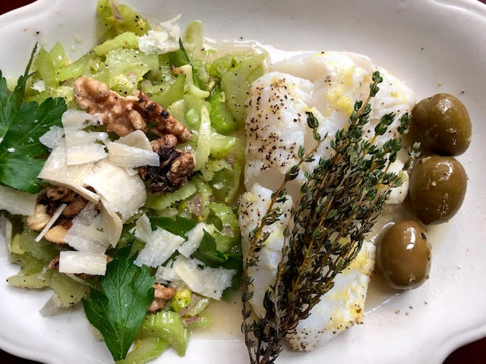
Ingredients:
1 head celery
1 tablespoon lemon juice
½ teaspoon celery salt

For the Lemon Vinaigrette:
Zest of 1 lemon
Juice of 1 lemon
½ cup olive oil
1 very small shallot, minced
2 teaspoons celery salt
½ teaspoon anchovy paste
1 teaspoon ground, black pepper
Parmesan cheese shavings, to taste
Chopped walnuts, to taste
A few leaves of Italian, flat-leaf parsley, to garnish the salad (optional)

Preparation:
Thinly slice one head of celery (including any leaves) on the bias. Dress the sliced celery with 2 – 4 tablespoons lemon juice. Also sprinkle in half a teaspoon of celery salt. Mix well and set aside.
Make a lemon vinaigrette by mixing the zest of one lemon and the juice of 1 lemon (should be about ¼ cup) with ½ cup olive oil, the minced shallot, the 2 teaspoons celery salt, ½ teaspoon anchovy paste and 1 teaspoon ground black pepper. Whisk well and pour over the sliced celery (the anchovy paste will perfectly emulsify the dressing, but it won’t give the salad any obvious anchovy taste).

Let the salad macerate in the fridge for a while before serving topped with big shavings of Parmesan cheese and some toasted, chopped walnuts (just warm them in a pan over medium-high heat, flipping them every minute or so, until you see them browned and smoking a little – season them with a sprinkling of salt). Dot the salad with a few, whole parsley leaves and serve as a side to baked fish, scampi pasta, or whatever you like.

