Baked Rigatoni with Meatballs and Hardboiled Eggs in Tomato Sauce

This recipe is perfect for that “Sunday gravy!” Recipe serves 6 – 8.

Ingredients:
4 ounces rigatoni pasta (I use whole-wheat rigatoni)
½ pound Italian sausage, out of the casing/bulk
1 big carrot, roughly chopped for the food processor
2 ribs celery, roughly chopped for the food processor
¼ cup roughly chopped white onion
¼ cup Italian, flat-leaf parsley
2 – 3 tablespoons olive oil
¼ cup Italian seasoned breadcrumbs
2 – 4 cloves garlic, minced
¼ teaspoon crushed red-pepper flakes, or to taste
1 28-ounce can whole San Marzano tomatoes, crushed by hand
4 large hardboiled eggs, sliced
1½ cups grated Parmesan cheese
1½ cups shredded or grated caciocavallo cheese (Glorioso’s sells it in Milwaukee)
4 ounces deli-sliced soppressata, cut into thin strips
Salt and ground, black pepper, to taste

Preparation:
Preheat your oven to 425° F. Start by making the tomato sauce, beginning with a pestata of onions carrots, garlic, celery and parsley – chop them finally in the food processor. Season everything with salt and pepper as you go from step to step.
Cover the bottom of a large pot or Dutch oven with olive oil and bring it to medium heat. Fry about ⅔ of the pestata until the onions are translucent. Add in the tomatoes and let simmer gently until you have a dense sauce, about 1 hour.
To the sausage, add the remaining ⅓ of the pestata, the beaten egg, the breadcrumbs, ¼ cup grated Parmesan cheese, salt, pepper and the crushed red-pepper flakes. Form into small meatballs by the tablespoon. Put them in the simmering sauce so they cook through while it becomes rich and dense.
Boil the rigatoni pasta in salted water until just al dente. Mix the cooked pasta in with the sauce and simmering meatballs. Grease a 2½-quart baking dish with olive oil. Spread half the pasta-meatballs sauce mixture along the bottom of the greased baking dish. Layer the slices of two hardboiled eggs over the pasta and meatballs. Layer on half of the soppressata strips. Sprinkle with grated Parmesan cheese and half the caciocavallo cheese. Repeat with a second layer.
Put the casserole, uncovered, in the preheated oven for 20 to 30 minutes, until the cheese is golden brown on top. Let it rest at least 20 minutes before serving.

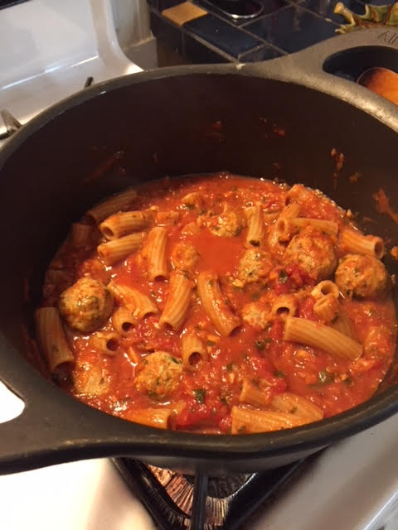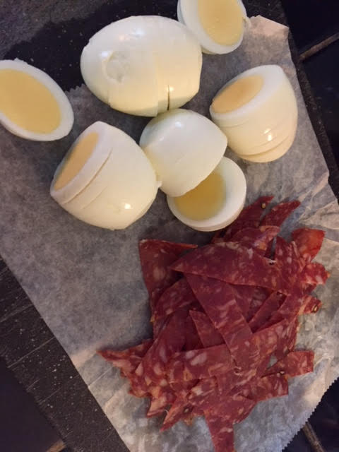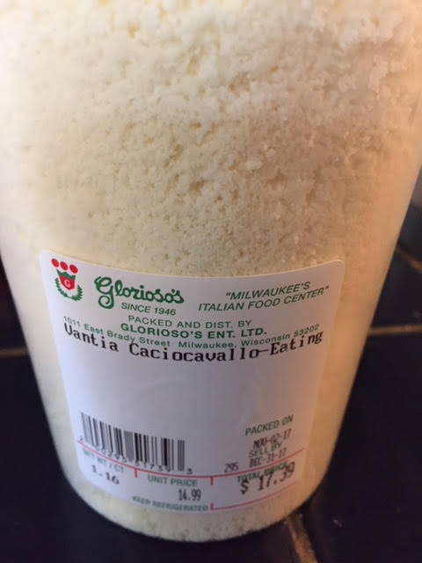

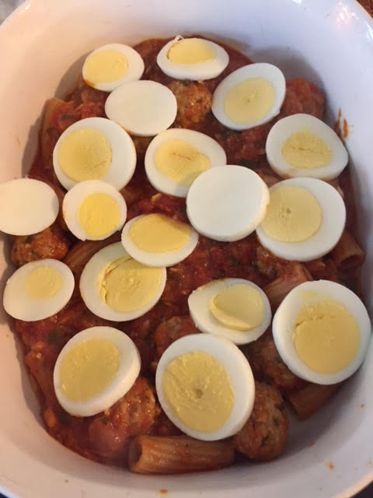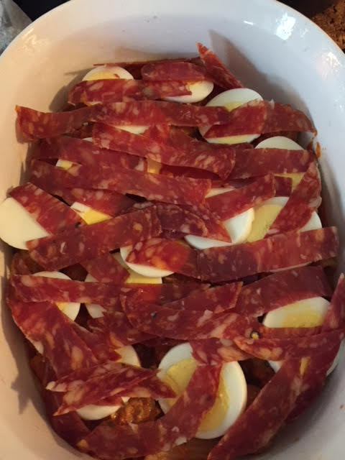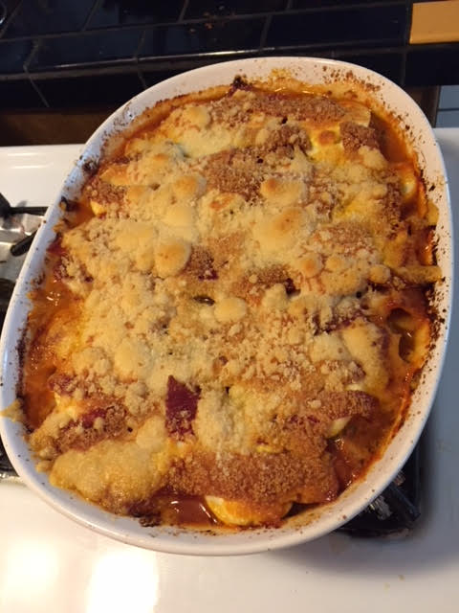

Generally speaking, the inclusion of hardboiled eggs in an Italian recipe means celebration, as in a holiday, wedding or other special event.

