Tuna-Stuffed Avocado

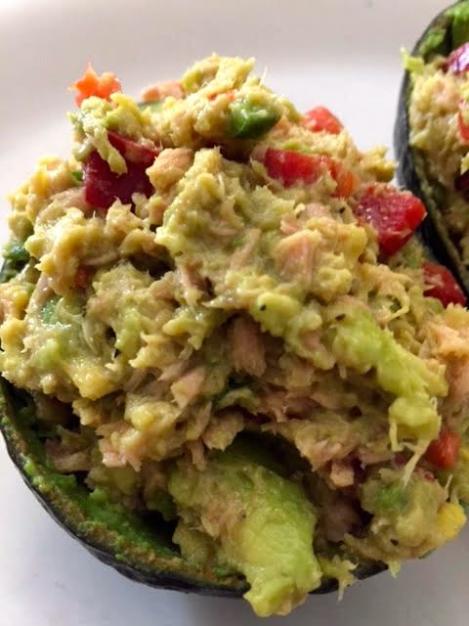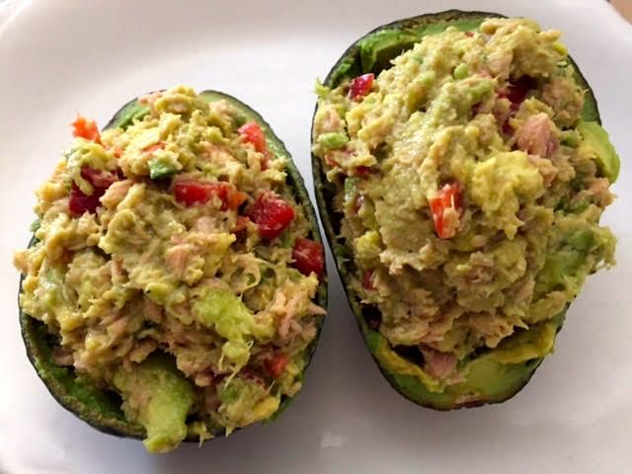

Ingredients per Serving:
1 larger-sized avocado
4½ ounces canned tuna, drained
¼ cup diced red bell pepper
1 small jalapeño, minced
¼ cup cilantro leaves, roughly chopped
3 tablespoons limejuice
Salt and ground black pepper, to taste

Preparation:
Slice the avocado in half and remove the pit. Scoop out most of the avocado from each half to make them into cups. Place the scooped avocado into a mixing bowl. Mash it with a fork. Add the tuna, bell pepper, jalapeño, and cilantro to the mixing bowl. Pour limejuice over. Stir it all together until everything is well mixed. Scoop half the tuna mixture into each avocado cup and season with salt and pepper.

