Hearty Spanish-Style Lentil & Chorizo Stew for Two

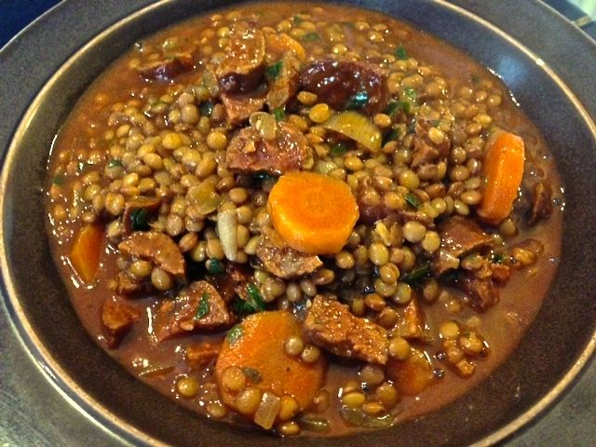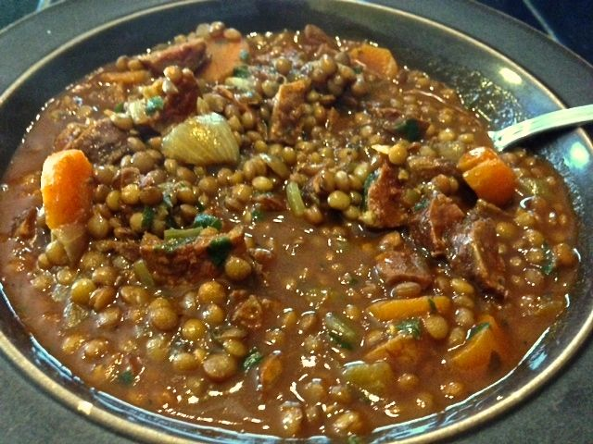

The lentils are tender in this smoky, meaty recipe, yet remain intact and not mushy, as is what happens typically with stewed lentils.

Ingredients:
8 ounces (a heaping cup) lentils (Spanish lentejas Pardina or French lentils dupuis), picked/rinsed
Salt and ground, black pepper
1 small onion
3 tablespoons olive oil
8 ounces hard-cured Spanish chorizo sausage, whole - remove the paper skin (I’ve found that the easiest way is with a vegetable peeler)
1 large carrot, peeled and cut into ¼“ pieces
5 teaspoons fresh parsley, minced
3 cups water, plus extra as needed
5 teaspoons sherry vinegar, plus extra for seasoning
1 bay leaf
⅛ teaspoon ground cloves
1 heaping tablespoon sweet smoked paprika
2 garlic cloves, minced
4½ teaspoons all-purpose flour

Preparation:
Place lentils and 1 teaspoon salt in a large bowl. Cover with 2 cups boiling water and let soak for 30 minutes. Drain well.

Meanwhile, finely chop three-quarters of the onion (you should have about ½ cup) and grate remaining quarter (you should have about 1½ teaspoons). Heat a tablespoon of oil in a large saucepan over medium heat until shimmering. Add whole chorizos and cook until browned on all sides, 5 minutes. Transfer chorizo to plate. Reduce heat to low and add chopped onion, carrot, 3 teaspoons parsley, and ½ teaspoon salt. Cover and cook on very low heat, stirring occasionally, sweat vegetables until they are very soft but not brown, 25 to 30 minutes. If vegetables begin to brown, add 1 – 2 teaspoons water to pot.

Add lentils and vinegar to vegetables; increase heat to medium-high; and cook, stirring frequently, until vinegar starts to evaporate, 3 to 4 minutes. Add 3 cups water, chorizo, bay leaf, and cloves; bring to simmer. Reduce heat to low, cover and cook until lentils are tender, about 30 minutes.

Heat remaining oil in small saucepan over medium heat until shimmering. Add paprika, grated onion, garlic, and ½ teaspoon pepper; cook, stirring constantly, until fragrant, 2 minutes. Add flour and cook, stirring constantly, 1 minute longer. Remove chorizos and bay leaf from lentils. Stir paprika mixture into lentils and continue to cook until flavors have blended and soup has thickened, 10 to 15 minutes. When chorizos are cool enough to handle, cut in half lengthwise, then cut each half into ¼”-thick slices. Return chorizo to soup along with remaining parsley and heat through, about 1 minute. Season with salt, pepper, and up to 1 teaspoon sherry vinegar to taste, and serve. Soup can be made up to 3 days in advance.

