Tortillitas de Camarones (crispy shrimp fritters) – recipe makes about 12 fritters

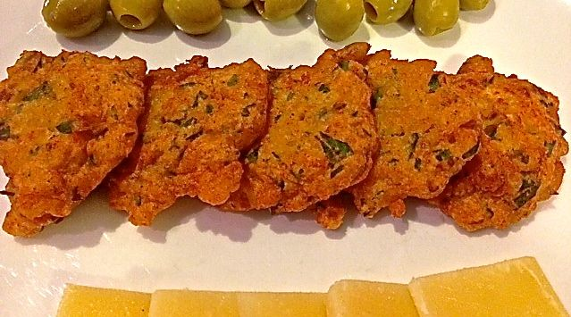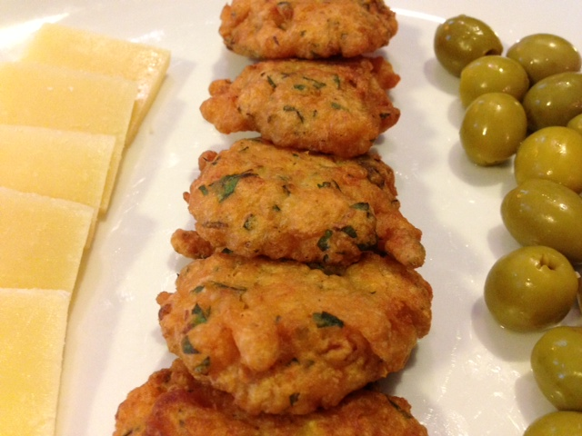

These crisp, delicious shrimp fritters are from Andalusia, Spain where deep-frying reigns supreme. They are at their best when made with chickpea flour (a hold-over from the Muslims), but regular flour is just fine. For the best results, fry only a few fritters at a time so that the oil temperature doesn't drop, as a constant high temperature keeps the tortillitas from absorbing excess oil. Even though the shrimp are minced, use small shrimp, which are more tender than large ones. And if you were shopping in Andalusia or in the Canary Islands, you would ask for camarones, just as you would in most of Central or South America, whereas everywhere else in Spain, you would ask for gambas.

Ingredients:
¼ pound (4 ounces) small shrimp
¾ cup chickpea flour (sold as “gram flour” at Indian grocery stores) or regular flour
1½ teaspoons (or as much as you like) chopped. fresh flat-leaf parsley
2 scallions, white part and a little of the tender green tops, finely chopped
½ teaspoon pimentón (Spanish paprika)
Salt and ground, black pepper, to taste
Olive oil for deep-frying

Preparation:
In a saucepan, combine the shrimp with water to cover and bring to a boil over high heat. As soon as the water starts to boil, quickly lift out the shrimp with a slotted spoon and set aside. Scoop out ½ cup of the cooking water and let cool. Discard the remaining water. When the shrimp are cool, peel them, devein them, cover and refrigerate until needed.

To make the batter, combine the flour, parsley, scallions and pimentón in a bowl or a food processor. Add a pinch of salt and pepper, and the cooled cooking water. Mix or process well until you obtain a texture slightly thicker than a pancake batter. Cover and refrigerate for 1 hour.

Remove the shrimp from the refrigerator and mince finely. The pieces should be about the size of coffee grounds. Remove the batter from the refrigerator, add the minced shrimp, and mix well.

Pour the olive oil to a depth of about 1 inch into a heavy sauté pan and heat over high heat until it is almost smoking. Add 1 tablespoon of the batter to the oil for each fritter and, using the back of the spoon, immediately flatten the batter into a round 3½” in diameter. Do not crowd the pan.

Fry, turning once, for about 1 minute on each side, or until the fritters are golden and very crisp with what Spanish cooks call puntillas, or lacelike formations, on the borders.

Using a slotted spoon, lift out the fritters, holding them briefly over the pan to allow the excess oil to drain, and transfer to an ovenproof platter lined with paper towels to drain further.

Keep the fritters warm in a low oven. Fry the rest of the batter in the same way, always making sure the oil is very hot before frying more fritters. When all the fritters are fried, arrange them on a platter and serve immediately.

