Portuguese Beef, Chorizo and Onion Stew (Alcatra) for Two

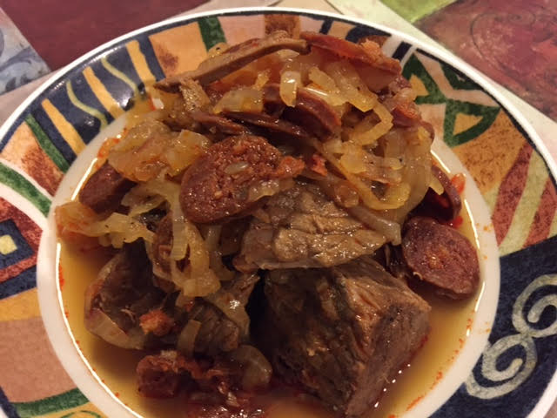

The cooking process for this spiced stew is unusually simple and unique (kind of like the Portuguese people themselves!), using only white wine to make the broth.

Ingredients:
2 pounds boneless beef rump roast, cut into 2½” pieces (big chunks)
4 – 6 whole garlic cloves, peeled and smashed with the back of a chef’s knief
6 – 8 allspice berries (more if they’re smaller than peppercorns)
2 bay leaves
1 teaspoon whole black peppercorns
1 large yellow onion, cut in half from root to root, then thinly sliced
3 cups Portuguese Vinho Verde, or any kind of dry white wine
¼ teaspoon ground cinnamon
4 – 6 ounces Spanish–style chorizo sausage, very thinly sliced (no more than ¼”)
Salt and ground black pepper, to taste

Preparation:
Preheat oven to 325°F. Using cheesecloth and string, make a bouquet-garni bundle with the garlic, allspice, bay leaves and peppercorns inside.

Put the sliced onions in a cold Dutch oven. Nestle the bouquet garni in the center of the onions, and season with salt and pepper. Poor in the wine (you can replace the wine with vegetable broth or even just water, but add a teaspoon of distilled white vinegar to replace the wine’s acidity), then nestle the pieces of beef into the onions around the edge of the pot's interior. Season the beef with salt and pepper and sprinkle the cinnamon over the top. Cover the pot and place in the oven for 3½ hours. Check the level of the broth every 30 minutes, adding more wine if needed.

After the 3½ hours of cooking, discard the bouquet garni, add in the chorizo slices, flipping over the beef and covering them as you stir them into the pot. Cover the pot and just let it rest on the countertop for 20 minutes. The stew is then done! Ladle the beef and onions into wide-rimmed bowls, spoon some of the sauce into each bowl over the beef and onions. Serve with a green salad.

