Mexican Pork-Loin Tostados (Lomitos de Valladolid – recipe makes 6 servings)

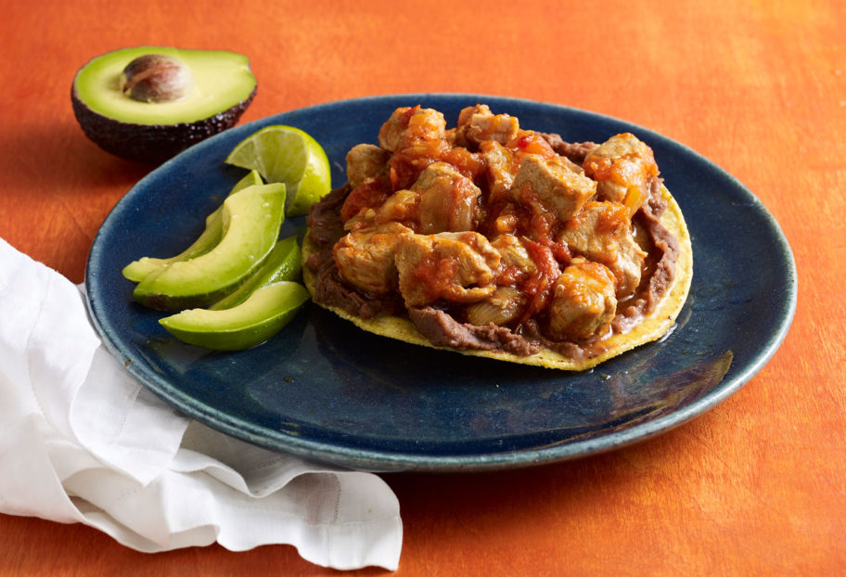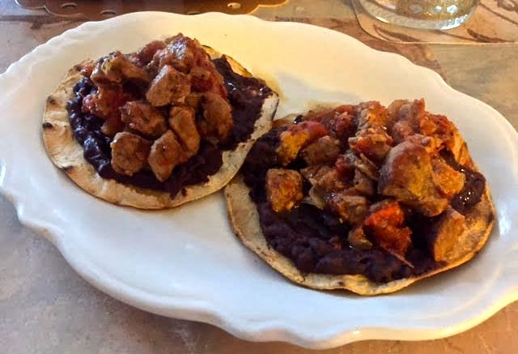

This easy recipe hails from the town of Valladolid (pronounced “vay-ya-dol-leed”) on Mexico’s Yucatán peninsula. The meat is normally only cooked for about 40 minutes, but I prefer Chef Patti Jinich’s recipe which calls for cooking it much longer.

Ingredients:
2 pounds pork tenderloin, cut into 1" cubes
1 tablespoon lard or vegetable oil
1 white onion, chopped
2½ pounds very ripe Roma tomatoes, chopped
6 corn tortillas
16 ounces refried black beans, warmed (those are the kind they eat in the Yucatán)
Salt and ground black pepper, to taste

Preparation:
Heat the lard or vegetable oil in a large pot or Dutch oven. Add in the pork and onion, cook until the onions are soft and then add in the tomatoes (though all the original recipes I’ve seen don’t call for them, I like to also add in about 2 – 4 cloves of minced garlic and ½ teaspoon of Mexican oregano). Season with salt and pepper, cover the pot, lower the heat to medium–low and let simmer 1 hour and 10 minutes. If it seems too soupy for your liking towards the end of the cooking time, just take the lid off and up the heat so the sauce can reduce.

Meanwhile, in a dry skillet, char the tortillas until somewhat blackened on both sides and a little chewy.

To serve, spread about 3 ounces of warmed refried beans on each blackened tortilla and top with lomitos. It’s also nice to dress these with a slice or two of avocado. I like a good sprinkling of Mexican hot sauce or sliced, fresh chilies on mine. Yum!

