Mexican Pork Carnitas for Two

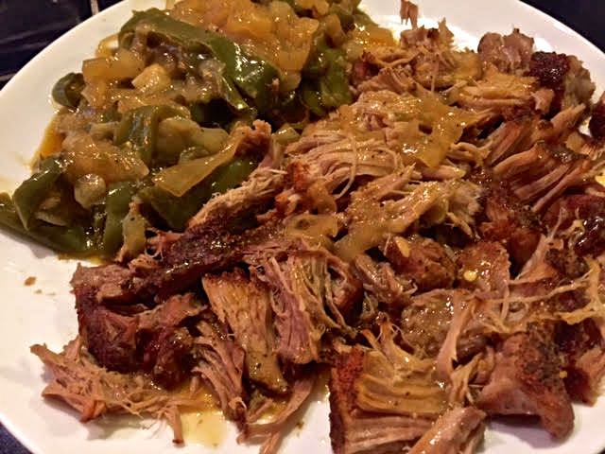

Ingredients:
2 honkin’-big, country-style pork ribs (about 1–1½ pounds, depending on bones)
1 medium-sized onion, halved and sliced into strips
2 poblano chilies, seeded and sliced lengthwise into strips (rajas in Spanish)
4 jalapeño chilies, seeded and sliced into rounds
¾ cup naranja ágria (sour orange juice), or the zest & juice of 1 orange and 1 lemon
1 cup chicken broth
1 teaspoon ground cumin
½ teaspoon salt
½ teaspoon ground, black pepper
½ teaspoon chili powder
¼ teaspoon ground cayenne, or to taste
Tortillas, warmed over the stovetop or for a minute in the microwave

Preparation:
Preheat oven to 350° F.

Combine the cumin, salt, black pepper, chili powder and cayenne; rub the pork well with the mixture on all sides (I wear latex gloves).

Spread the chilies and onion over the bottom of a Dutch oven, then season them with a sprinkling of salt and pepper. Pour the zest/juice over them. Place the spice-rubbed pork over them. Pour the broth in around the sides of the pork.

Put the lid on the pot and bake 2½ hours, until the meat is tender and can easily be shredded (but don’t shred it just yet – see next step).

Remove the lid and increase the oven heat to 450° F. Bake, uncovered for another 20 minutes, until the pork gets nice and crispy on the outside.

Shred the pork and serve with the vegetables (with the pot juices drizzled all over them) and warm tortillas to wrap them in.

